TREND LETTER I Winter 2021

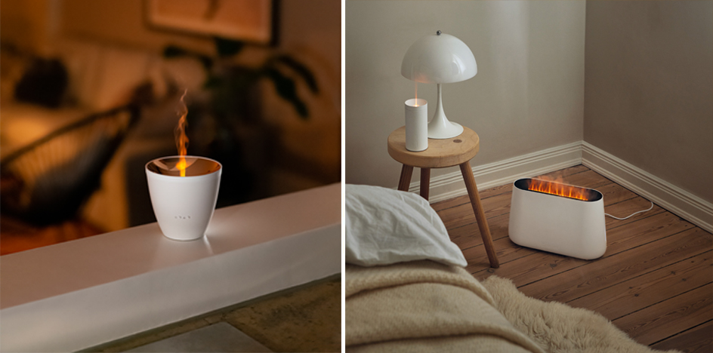

Fragrance and flame for the winter months
Stadler Form presents innovative Christmas presents
Every year at the start of the Advent season, the search for special Christmas presents begins. What could be better than a present that immediately turns your home into a stress-free oasis of well-being? Thanks to their innovative technology, Zoe, Lucy and Ben from Stadler Form create an atmospheric ambience with dancing flames without producing any soot or heat.

The glamorous Zoe
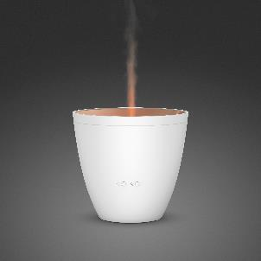
Elegant, innovative and handy: meet Zoe from Stadler Form. The aroma diffuser lady creates a modern oasis of well-being by filling the room with your favourite fragrance in her own stylish way. At the press of a button, energy-efficient ultrasonic technology ensures that the extra-fine mist is optimally distributed around the room.

Zoe’s special features: The mist rises from the bronze-coloured bowl with its elegant metal look and the clever Amber Light™ creates an amber-coloured dancing flame. Zoe is the first product from Stadler Form to be designed with this type of technology and with a flame effect. The ideal present for anyone who likes glamorous decor and essential oils.

Aroma diffuser Zoe from Stadler Form, current market price CHF 49.90

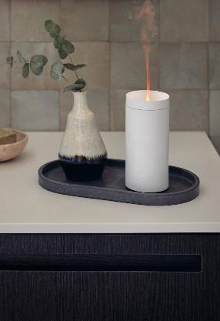
The illuminating Lucy
With her deceptively realistic candlelight, aroma diffuser Lucy makes the perfect table decoration for a romantic candlelit dinner or the perfect companion for cosy evenings at home. Her ultrasonic technology enables her to silently fill the room with fragrance from essential oils in the form of a fine mist of water.

Lucy’s special features: The aroma diffuser from Stadler Form is operated using a rechargeable battery rather than mains power, making Lucy a technical innovation. Thanks to a battery runtime of up to seven hours and a USB cable, Lucy can be moved around quite easily and continue to work her magic throughout the evening. The ideal present for anyone who goes for simple design.

Aroma diffuser Lucy from Stadler Form, current market price
CHF 49.-

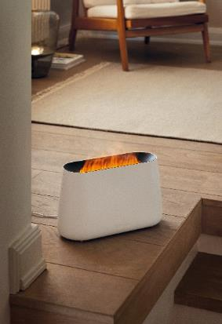
The talented Ben
Ben creates the feel-good atmosphere of an open fire in your living room. Thanks to his Amber Light™, he produces a realistic dancing flame without the need for a fireplace and without producing any soot. You can steplessly adjust the intensity from a gentle flame to a small open fire. Ben can be used at any time of the day or night as the flame effect and illuminated water level indicator can be dimmed or switched off altogether.

Ben’s special features: The dancing flame not only creates a cosy ambience but also humidifies and fragrances the indoor air at the same time – a 3-in-1 talent and a technical innovation from Stadler Form at the same time. The ideal present for anyone who appreciates versatile functionality.

Ben from Stadler Form, current market price CHF 129.-

All three devices from Stadler Form are ready to go in no time at all: fill with water up to the mark, then add a few drops of your favourite essential oil and they’re ready! There are five different natural essential oil mixtures from Stadler Form to choose from for Zoe, Lucy and Ben: Recharge, Relief, Refresh, Relax and Revive.

Zoe, Lucy and Ben from Stadler Form are available now at stadlerform.com and from selected specialist stores and their online shops. All three products come in White and in Black.

Please do not hesitate to contact us for further information.

Press contact:
Silvia Acerra
Flowcube Communications | E-mail: silvia.acerra@flowcube.ch | Tel. +41 (0)43 344 30 35

