PRESS RELEASE I April 2023

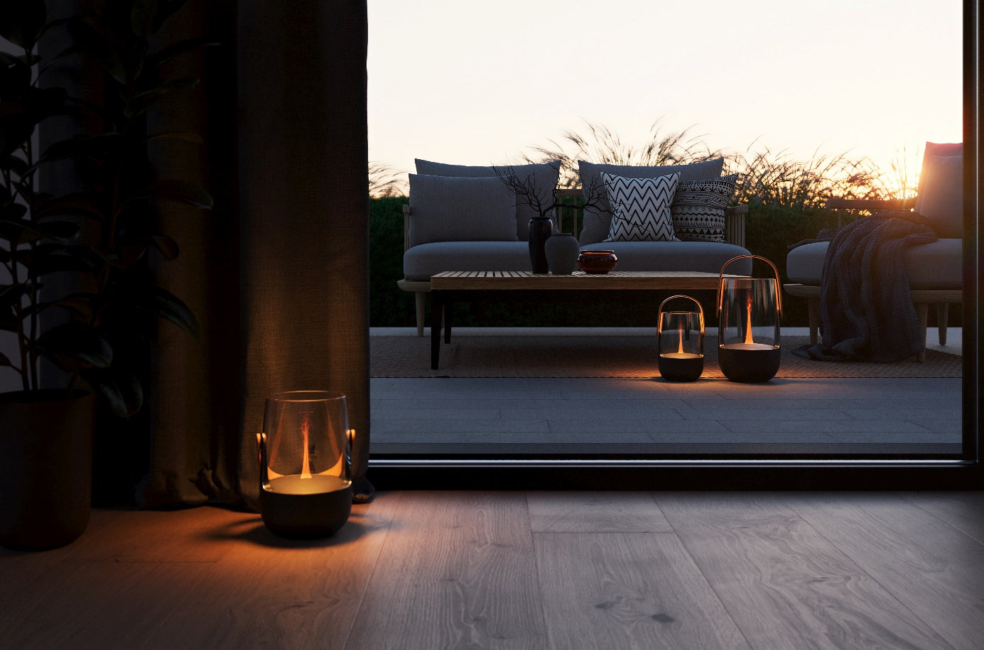
2-in-1 aroma diffuser and lantern for indoors and outdoors
Stadler Form launches Sophie and Sophie little – innovative and elegant

Spring is back and with it the desire to enjoy sunshine as well as starry skies out on the balcony or in the garden. For the first time, Stadler Form launches two aroma diffusers with an integrated lantern for indoor and outdoor use: Sophie and Sophie little. Both create real feel-good moments and ensure atmospheric evenings in and around the house.

Stylish innovation

Fragrance sensation and cosy play of light for indoors and outdoors? With Sophie this is possible. The innovation from Stadler Form has amazing multi-functionality: she is an aroma diffuser and lantern at the same time. She can be moved around, making her suitable for indoor use, on the terrace or in the garden. Her stylish design with an elegant bamboo handle makes her a real eye-catcher. Using ultrasonic technology, the desired fragrance is silently distributed as a fine mist. Thanks to the Amber LightTM Sophie creates an atmospheric flickering flame. So refined the fragrant mist produced using ultrasonic technology, so easy the use: fill the device with water, add two to three drops of essential oil and relax. There is a variety of natural essential oil mixtures from Stadler Form to choose from.

Stadler Form CEO Martin Stadler explains


What makes Sophie so special?

«Sophie is no ordinary aroma diffuser, she also has an integrated lantern, making her a first for Stadler Form. Another of Sophie’s unique features is her versatility. She can be used both outdoors as well as indoors and with her functional design, she can be carried around comfortably without spilling any water. The device is charged using a USB-C cable and can be operated with a battery for up to 11 hours. She is both quiet and energy-saving during operation. There is a dimmer button on the device so that you can save energy and adjust the brightness of the illuminated mist as you wish.»
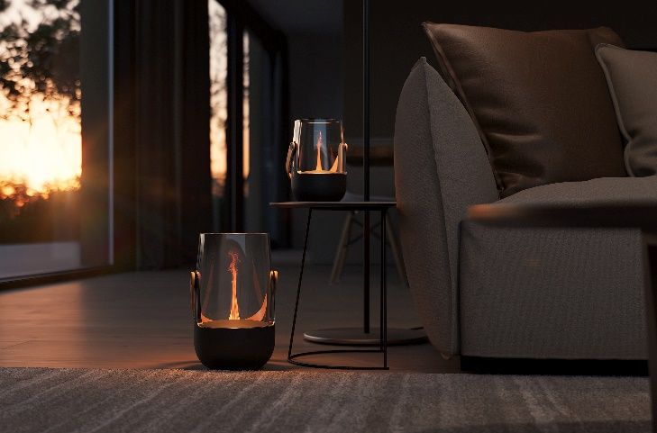
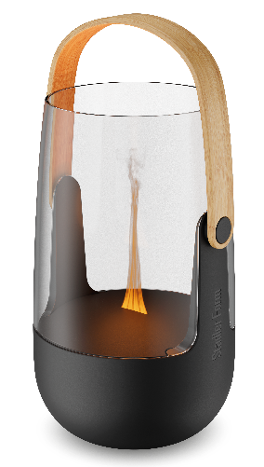
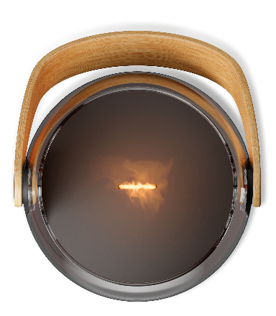

What are the benefits of an outdoor aroma diffuser?

«The amber-coloured light produced by the Amber LightTM turns the cool mist into a fragrant flickering flame. With a suitable essential oil, she can also be used outdoors as an insect repellent. To operate Sophie, fill her with water first and then add two to three drops of your favourite essential oil directly to the water. The aroma diffuser with integrated lantern can then be switched on and nothing stands in the way of a cosy spring evening.»
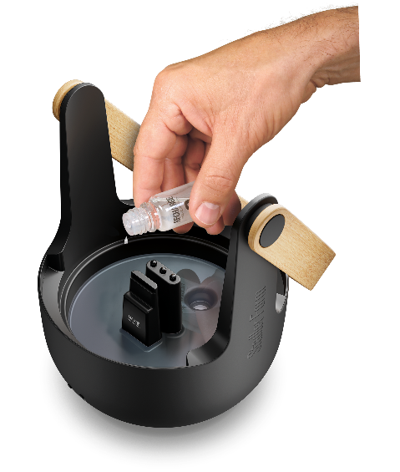
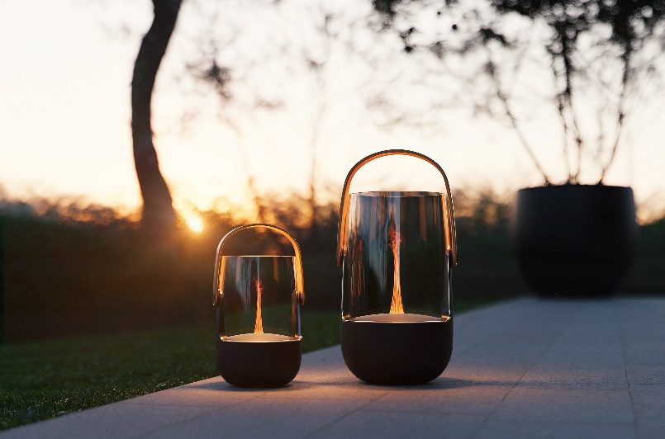

How long did the design process take and what challenges had to be overcome?

«The technical innovation took two years to develop by working in collaboration with our Swiss designer Fabian Zimmerli. During the process, there were intensive brainstorming on how we could design an aroma diffuser with integrated lantern function for indoor and outdoor use. An IP44 certification is required to ensure safe use in covered outdoor areas which brings with it special technical requirements. Sophie and Sophie little are the first devices from Stadler Form that are certified for 0utdoor use. We are very happy with the end result and sure that she will become an absolute summer highlight.»

Aroma diffuser Sophie from Stadler Form, current webshop price CHF 99.-
Aroma diffuser Sophie little from Stadler Form, current webshop price CHF 79.-

Aroma diffuser Sophie from Stadler Form will be available in two sizes from the 4th of April 2023 via stadlerform.com and in selected specialist stores as well as their online shops.

Please do not hesitate to contact us for further information.

Press contact

Silvia Acerra
Flowcube Communications | E-mail: silvia.acerra@flowcube.ch | Tel. +41 (0)43 344 30 35

