PRESS RELEASE I May 2024

For a fresh breeze indoors and outdoors
Stadler Form launches two versatile fans: Finn and Finn mobile

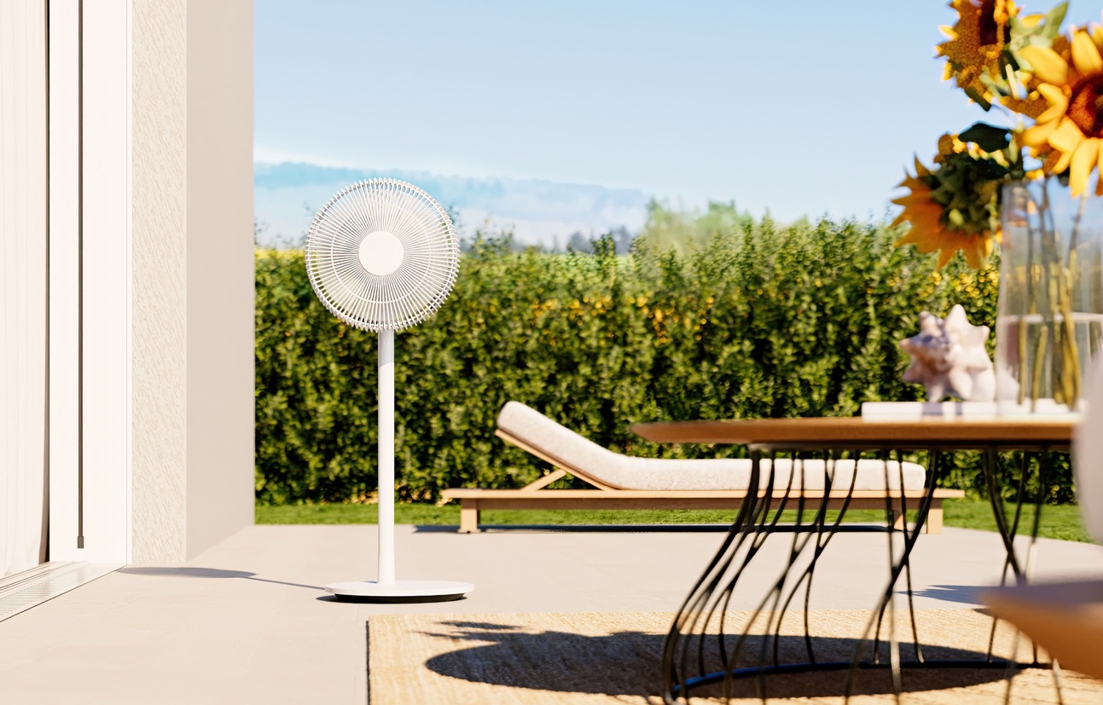
With the arrival of summer, the temperature not only rises outside, but also inside your own four walls. Whether in the bedroom, living room or on the balcony - on hot days you often wish for a cool breeze. Fans can help by circulating the air and thus providing refreshment. On 6 May, Stadler Form launches Finn and Finn mobile, two roommates that impress with their attractive design, powerful performance and quiet operation. Finn mobile is particularly innovative: he can also be used outdoors thanks to his battery operation with an impressive battery life of up to 35 hours.
"We are very happy to welcome Finn and Finn mobile to the Stadler Form family, which were developed in collaboration with Swiss product designers Fabian Bernhard and Thomas Burkard,. With their stylish design, our new fans blend harmoniously into any interior and provide outstanding refreshment with minimal noise. Finn and especially Finn mobile with his integrated battery are extremely flexible helpers against the heat" says Martin Stadler, CEO of Stadler Form.
These highlights make the new fans from Stadler Form ideal summer companions:
- Flexible use
Both Finn and Finn mobile can be used as pedestal, floor or table fans. The removable pole can be easily inserted or removed depending on the requirements and situation. The two fans can therefore be placed throughout all areas of the living space and on different surfaces to suit individual preferences. For those who want an even more versatile fan, Stadler Form now also offers a solution for covered outdoor areas with the battery-powered Finn mobile.
- All-round refreshment for day and night
As soon as you switch on the swing function on Finn and Finn mobile, the fan head automatically moves horizontally at a 120° angle. This ensures that the air is distributed evenly. Particularly practical: the swing function can be stopped in the desired position. The vertical position of the fan head can be adjusted manually with an angle of up to 90°. The eight speed settings with a wind distance of up to eight meters allow a gradual adjustment from a gentle breeze to a strong wind. Especially during hot nights, air circulation promotes a good night‘s sleep. In night mode, the LEDs are switched off and the fan switches to the lowest wind setting that you can fall asleep undisturbed. Another highlight: the 1–8 hour timer ensures that the fans switch off automatically after a certain time.
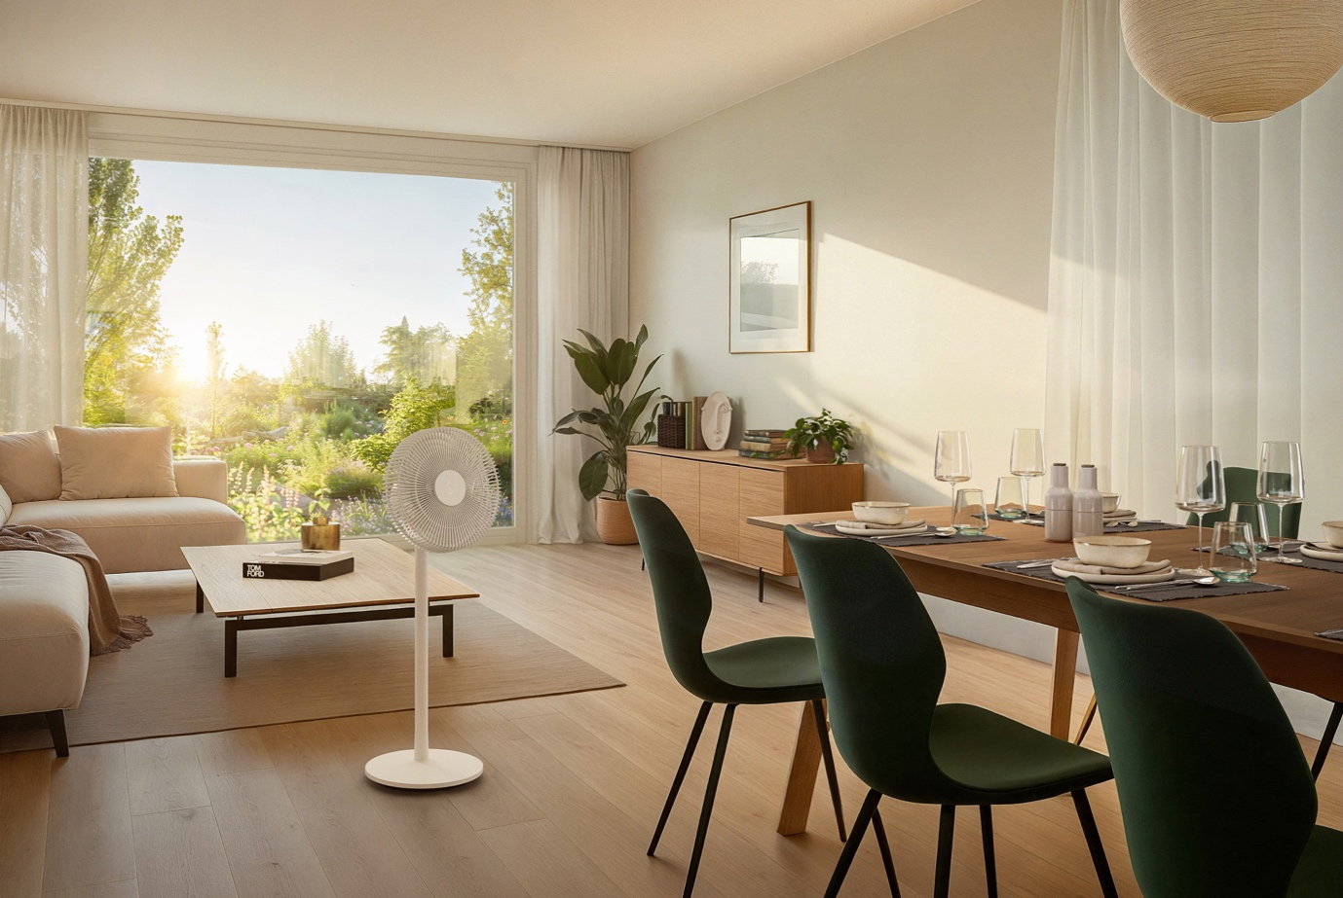
- Energy-efficient and easy to maintain
The energy consumption of technical appliances is an important issue these days. With a very low power consumption starting at 1.6 watts, Finn and Finn mobile are extremely energy-efficient fans. Just like their operation, their maintenance is also easy and uncomplicated: the grille can be removed to easily clean the fan blades.
- Innovative enhancement for outdoors
When the air is stagnant in summer, you long for a fresh breeze outside on the balcony or terrace. Thanks to his rechargeable battery and IP44 certification, Finn mobile is the first fan from Stadler Form to provide refreshing sea breeze even in covered outdoor areas. On level 4 and with the swing function, his battery lasts for 7 hours. Alternatively, Finn mobile can be connected to the power supply by cable. The battery status display, which is switched on at the touch of a button, shows the current battery charge level.
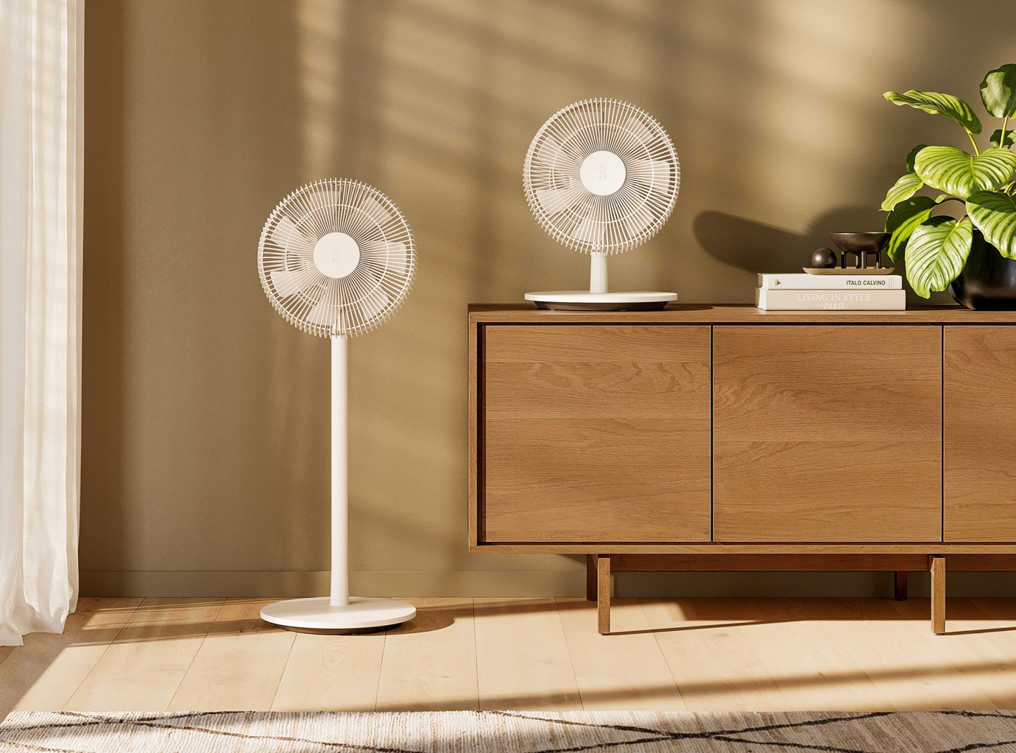

Finn from Stadler Form, current webshop price, Fr. 114.-
Finn mobile from Stadler Form, current webshop price, Fr. 159.-

Finn and Finn mobile by Stadler Form are available from 6 May 2024 on stadlerform.com, in selected specialist shops and their online shops.
Watch Video
Please do not hesitate to contact us for further information.

Media contact

Silvia Acerra
Flowcube Communications AG | E-Mail: silvia.acerra@flowcube.ch | Tel. +41 (0)43 344 30 35

