PRESS RELEASE I October 2022

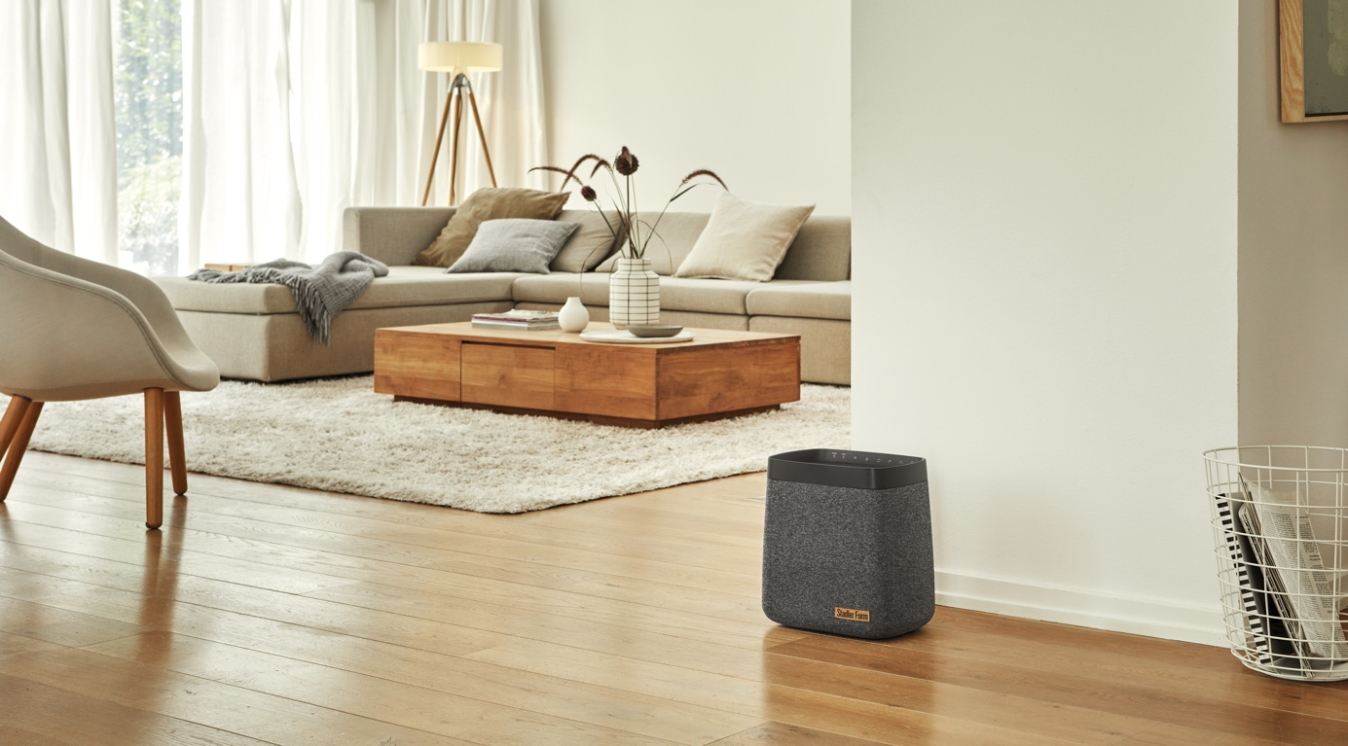
«There’s something in the air: the new generation of humidifiers is coming»
Product launch: Stadler Form presents humidifiers Karl and Karl big
During the cold months of the year the air indoors at home and in the office becomes very dry quickly when the heating is on. Humidifiers can bring relief and provide ideal humidity as well as improve well-being. Stadler Form is a design brand for air treatment products that is launching a new generation of humidifiers on 10 October 2022. Karl and Karl big are two energy-efficient models that stand out from the crowd with their powerful performance, elegant design and modern textile cover.

Humidifiers with superpower

Optimal indoor climate is not a new trend – not having the right level of humidity can have a negative impact on well-being. With the new generation of efficient humidifiers – Karl and Karl big – an optimal indoor climate is guaranteed even in large rooms. Through collaboration with Swiss designer Matti Walker, Stadler Form has developed a new generation of evaporators. Not only do they exceed all the technical demands made on them, but they also look timeless with their anthracite textile cover, making them ideal for integrating into the individual atmosphere in the room.

Stadler Form CEO Martin Stadler explains



When do you use a humidifier?

«In heated spaces indoors, the air is often too dry. For some people, this can cause watery eyes, a scratchy throat and even headaches or trouble sleeping. It is important to monitor the humidity at home regularly using a hygrometer. When the relative humidity lies below 40% during the cold months of the year, a humidifier can help to restore optimal humidity in a room during the day and at night.»
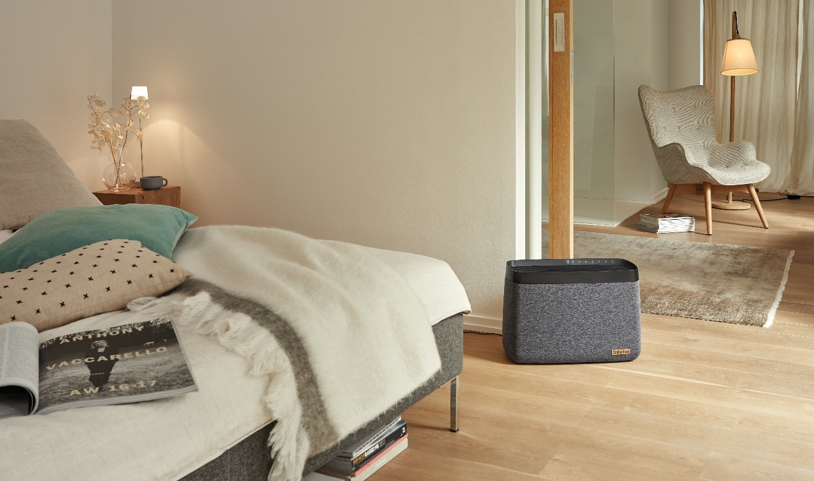
What is the difference between Karl and Karl big?

«Karl is compact and suitable for large rooms of up to 100 m² with his 4.6-litre water tank and high humidification performance. He will integrate perfectly with the existing décor in your bedroom or living room. High-performance powerhouse Karl big, with his generous 11-litre water tank, can humidify rooms of up to 150 m² in no time at all.»
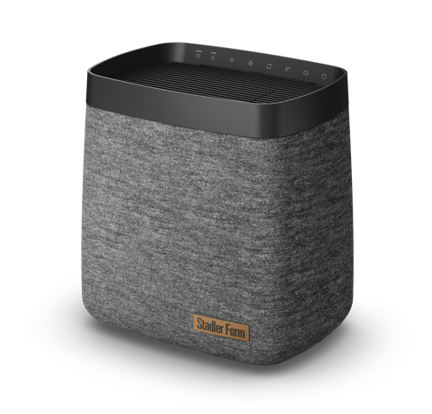
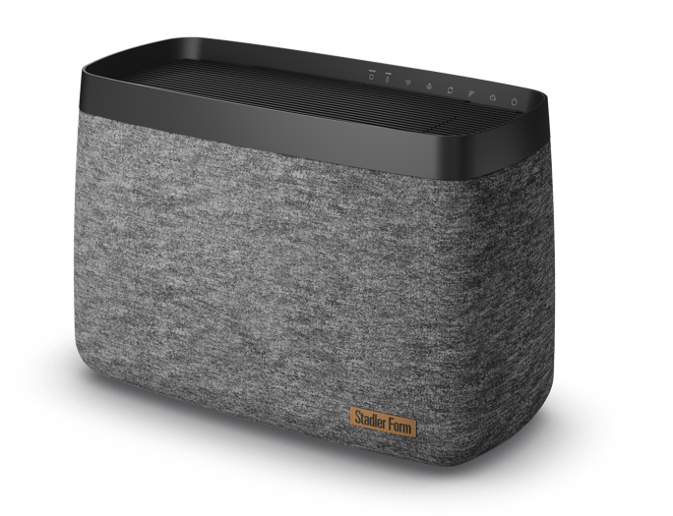
How energy-efficient and sustainable are the new humidifiers?
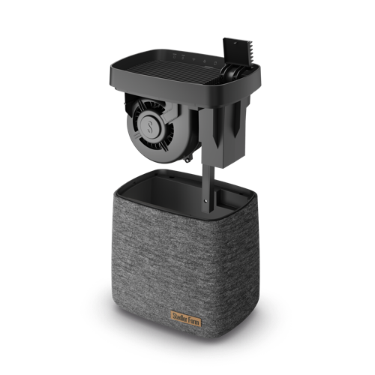
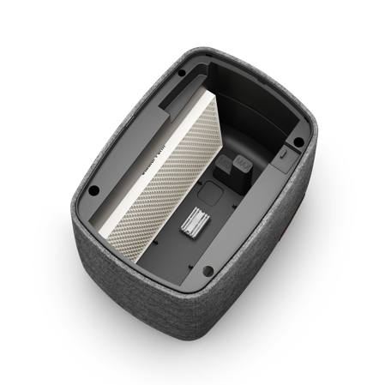
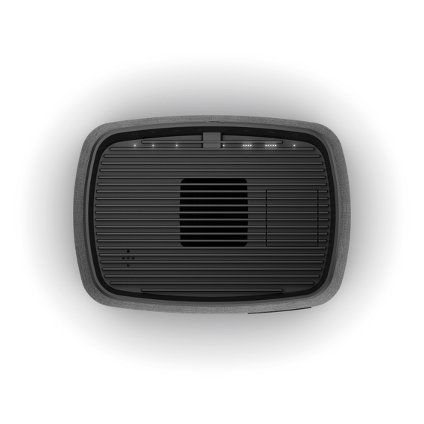
«In Auto mode, Karl and Karl big select the appropriate level of humidification themselves. So, the desired level of humidity in the room can be achieved and maintained quickly while saving energy. The innovative construction enables the humidifiers to be kept compact. The efficient design, together with the economical DC motor, results in low energy consumption. The devices switch off automatically as soon as the water tank is empty. Also, the humidifier filters are made from plant and textile fibres.»

What additional functions do the new generation of humidifiers offer?

«Because Karl and Karl big are equipped with WiFi, all their functions can be controlled via an app on your smartphone and you can also check the level of humidity at any time, even when you are out and about. A particularly practical feature for customers is the lift-up opening that enables the devices to be filled with water from the top while they are in operation. In addition, the LED function lights can be dimmed or switched off altogether during the night so that your sleep will not be disturbed.»

Humidifier Karl from Stadler Form, current webshop price CHF 259.00

Humidifier Karl big from Stadler Form, current webshop price CHF 379.00

Humidifiers Karl and Karl big from Stadler Form have been available since 10 October 2022 at stadlerform.ch and from selected specialist stores and their online shops.

Please do not hesitate to contact us for further information.

Press contact

Silvia Acerra
Flowcube Communications | E-mail: silvia.acerra@flowcube.ch | Tel. +41 (0)43 344 30 35

