TRENDLETTER I Autumn/Winter 2022

Enjoy the winter thanks to an optimal indoor climate

Three Stadler Form humidifiers to meet every need
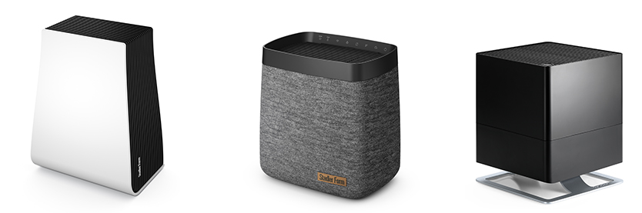

Once again, the days are getting shorter, darker and colder. The heating is permanently on, so as a result indoor air is very dry. Wellbeing and health suffer and symptoms such as tiredness and lack of motivation build up. But it is possible to make a successful start to the colder months. A humidifier from Stadler Form helps to create a better indoor climate with a feel-good atmosphere during the winter months. Stadler Form is a design brand for air treatment products and, in Karl, Oskar and George, offers three solutions to suit different types of accommodation and needs.

George for the health conscious
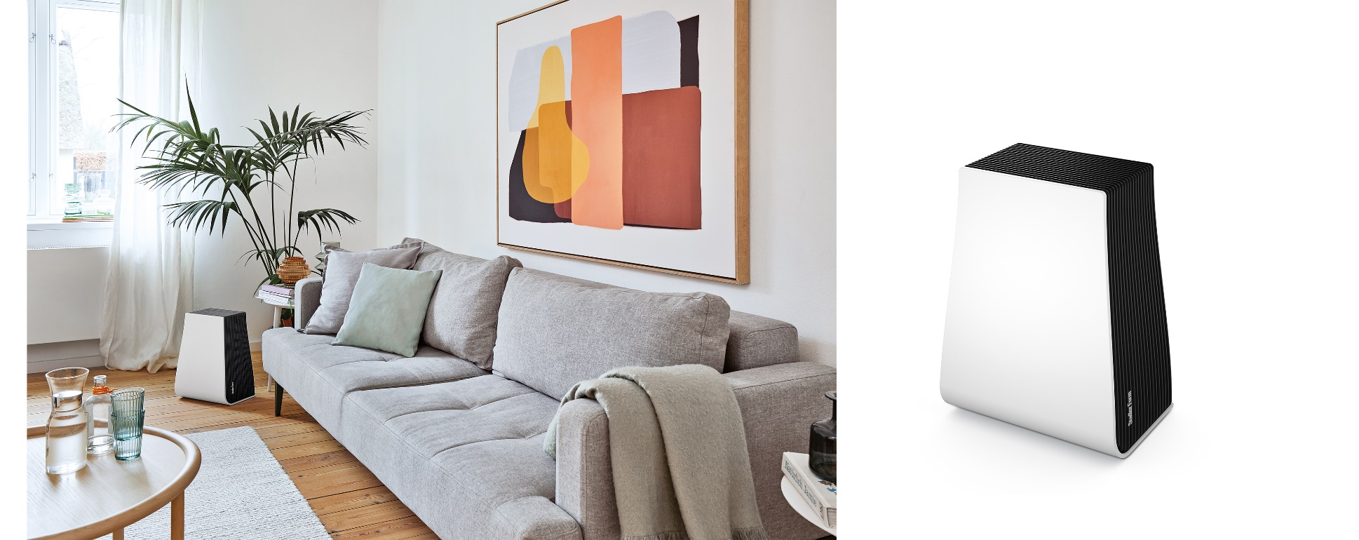
The most frequent signs of excessively dry air are tight-feeling skin, headaches and runny eyes. 2-in-1 talent George can help – bringing blessed relief for people who suffer from allergies too. He provides optimum humidity and clean air at the same time by the discs that rotate in water, filtering small particles out of the air. If you add essential oils to the fragrance container, George will distribute your favourite scent around the room, creating an atmospheric, relaxing oasis where you can make it through the winter feeling fit and energised.

Humidifier and air purifier George from Stadler Form, current webshop price CHF 219.-

Clean air matters very much to blogger and two-time mum Laura, as her son suffers from a severe pollen allergy. With his 2-in-1 function, air purifier George provides great relief for the whole family. Thanks to his sleek design, Stadler Form’s new housemate also fits perfectly into her home décor.

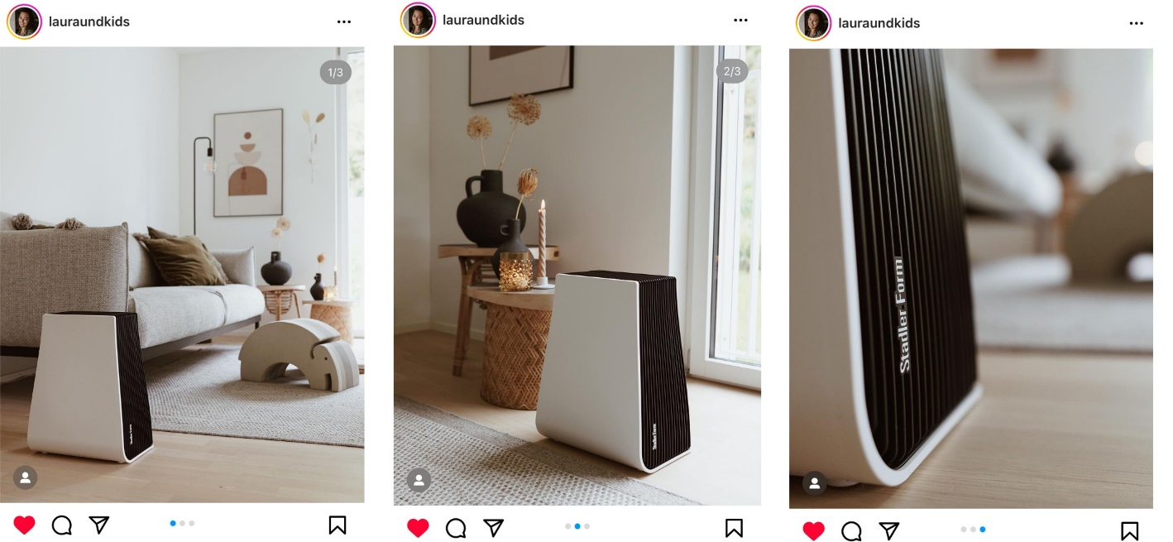

Click here for the post by lauraundkids

Karl and Karl big for lovers of design

Lean back, relax and take a deep breath: Karl and Karl big make this possible, even if the winter blues is taking hold within your four walls. With the new generation of efficient humidifiers from Stadler Form, issues such as a scratchy throat in the morning and possible colds caused by too dry air are counteracted. Karl and Karl big ensure the indoor climate reaches the optimum in both big and small rooms. As a result of outstanding technical performance, such as high output yet very low power consumption, the new humidifiers win people over with their beautifully shaped design and modern textile cover. The perfect choice for anyone who values design and functionality.
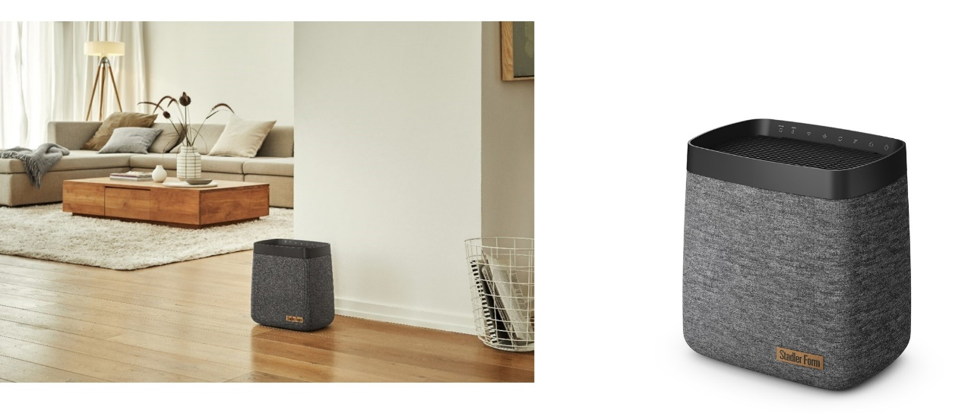
Karl humidifier from Stadler Form, current webshop price CHF 259.-
Karl big humidifier from Stadler Form, current webshop price CHF 379.-

Oskar for newly minted parents

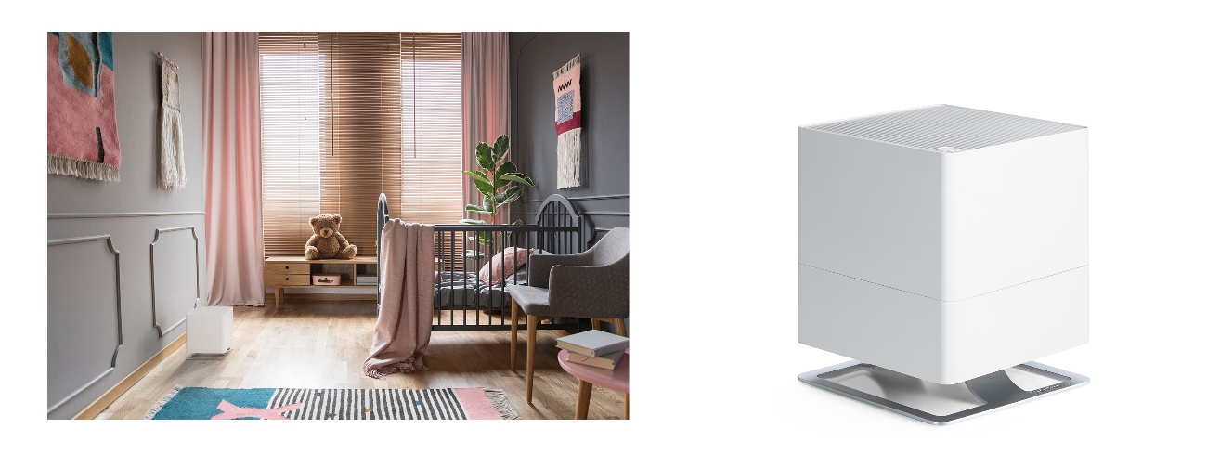
A poor indoor climate and insufficient humidity have a particularly negative effect on the well-being of babies and toddlers. They are more sensitive to changes in temperature and the air because their immune systems are immature. The trio of Oskar evaporators from Stadler Form maintain relative humidity at a constant level, so that young and old feel energetic and healthy. You need have no worries about operating the evaporator at night either, due to dimmed LEDs and very quiet operation. In this way Oskar guarantees restful sleep for the whole family.
Oskar humidifier in white, current webshop price, CHF 139.-
Oskar little humidifier in white, current webshop price CHF 99.-
Oskar big humidifier in black, current webshop price CHF 199.-

The Karl, Oskar and George humidifiers from Stadler Form are available on https://www.stadlerform.com from selected specialist retailers and their online shops.

Please do not hesitate to contact us for further information.

Media contact

Silvia Acerra
Flowcube Communications | E-mail: silvia.acerra@flowcube.ch | Tel. +41 (0)43 344 30 35

