TREND LETTER I Winter 2022

Fragrant dancing flame
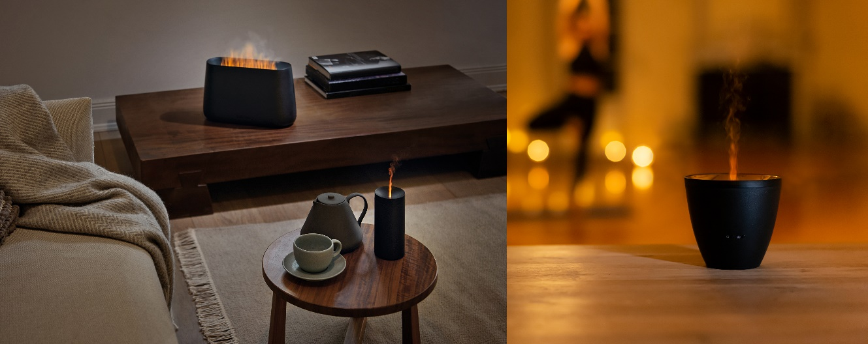
Stadler Form presents three gift ideas for Christmas
Every year in the run-up to Christmas, the feverish search for the perfect gift begins. It should be highly individual and give a lot of pleasure. That’s why Ben, Lucy and Zoe from Stadler Form – the design brand for air treatment products – make ideal gift ideas. Thanks to their innovative technology, they create an atmospheric ambience with flickering light effects.

Gift idea #1: The talented 3-in-1 Ben

Lean back, take a deep breath and feel good: the multifunctional Ben from Stadler Form creates a cosy atmosphere, humidifies the indoor air and emits a subtle fragrance. Even if you haven’t got a fireplace, you can enjoy the feeling of an open fire – thanks to Ben. The Amber Light™ produces a realistic dancing flame without the need for a fireplace and without producing any soot. You can steplessly adjust the intensity from a gentle flame to a flickering play of fire. A little note for anyone who is design-conscious: Ben won the Red Dot Design Award 2022 and the German Innovation Award 2022.

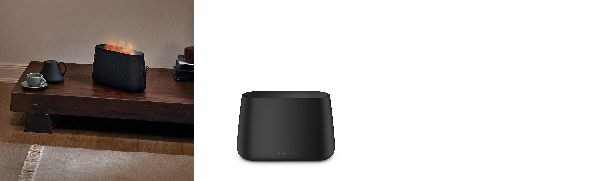

Ben from Stadler Form, in Black and White, current webshop price Fr. 99.90.-

Gift idea #2: The fragrant and illuminating Lucy

A romantic candlelight dinner? No problem with aroma diffuser Lucy from Stadler Form. Her simple design makes her perfect for placing on a beautifully laid table. Lucy bathes the room in soft light and fills it with a subtle fragrance in the form of a fine mist created by adding essential oils and dispersed by means of ultrasonic technology. As Lucy can be operated using a rechargeable battery, she can be moved around quite easily. Her deceptively realistic candlelight creates a cosy atmosphere and guarantees soothing relaxation.

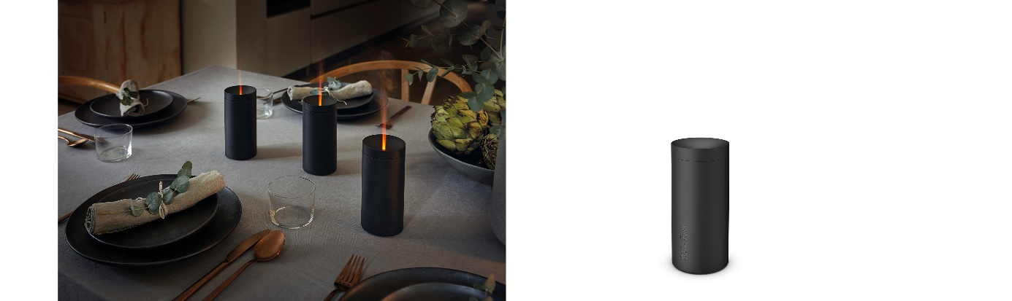

Aroma diffuser Lucy from Stadler Form, in Black and White, current webshop price Fr. 49.00

Gift idea #3: The handy and glamorous Zoe

Zoe from Stadler Form turns any room into an oasis of well-being. The mist rises from the bronze-coloured bowl with its elegant metal look and the clever Amber Light™ creates an amber dancing flame. At the press of a button, energy-efficient ultrasonic technology will ensure that the extra-fine mist is optimally distributed around the room. A little note for anyone who is design-conscious: Zoe won the Red Dot Design Award 2021.

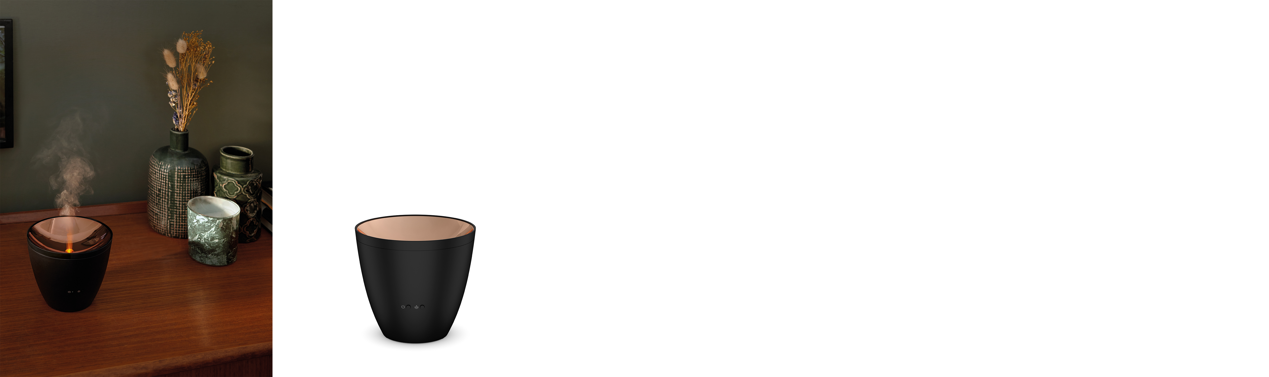

Aroma diffuser Zoe from Stadler Form, in Black and White, current webshop price Fr. 59.00

All three devices are ready for use in no time at all:

- Fill with water up to the mark
- Add a few drops of your favourite essential oil
- Switch on and relax

There are five different natural essential oil mixtures from Stadler Form to choose from for Ben, Lucy and Zoe: Recharge, Relief, Refresh, Relax and Revive.

Ben, Lucy and Zoe from Stadler Form are available now at stadlerform.com and from selected specialist stores and their online shops.

Please do not hesitate to contact us for further information.

Press contact
Silvia Acerra
Flowcube Communications | E-mail: silvia.acerra@flowcube.ch | Tel. +41 (0)43 344 30 35

