TRENDLETTER I Autumn/ Winter 2024

A cosy atmosphere for the cold season

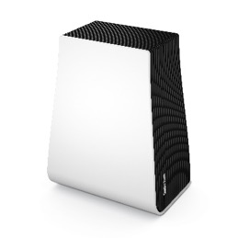
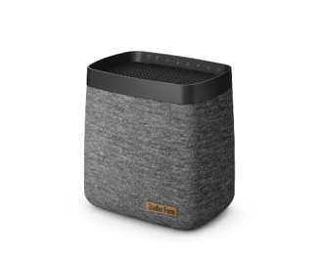
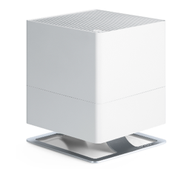
Stadler Form presents humidifiers and air washer for every living and working space

In recent years, autumn often no longer announces itself gradually, but follows abruptly after the summer heat. The sudden change of the weather brings not only the cold but also dry indoor air, which is intensified by heating. This can lead to irritated airways, dry eyes and difficulty with concentration. Stadler Form's humidifiers and air washer offer the perfect solution for balanced air conditions and create a pleasant living and working environment. With Oskar, Karl and George, an optimal indoor climate is easily achieved.

Oskar-Trio: the quiet companions
In the cool autumn and winter months, dry airways and skin can often lead to discomfort and restless sleep, with the effects of the dry air felt most intensely upon waking. To maintain a constant level of humidity and promote health and vitality, Stadler Form offers the trio of humidifiers Oskar, Oskar big or Oskar little. Additionally, their timeless design complements any interior design.
What are the benefits of the Oskar trio?

- Precise humidity control: Thanks to the integrated hygrostat, humidity is efficiently controlled.
- Night mode: In night mode, the LEDs can be dimmed or switched off completely to ensure total darkness.
- Quiet operation: the Oskar trio is ideal for rooms where a quiet but powerful device is needed.

Where can they be used?

- Room size: Oskar is available in three sizes. Oskar little is suitable for rooms up to 30 m², Oskar for up to 50 m² and Oskar big for areas up to 100 m².
- Where to use: They are ideal for bedrooms and children's rooms, or even for home offices. The night mode and quiet operation ensure undisturbed sleep and high concentration when working.

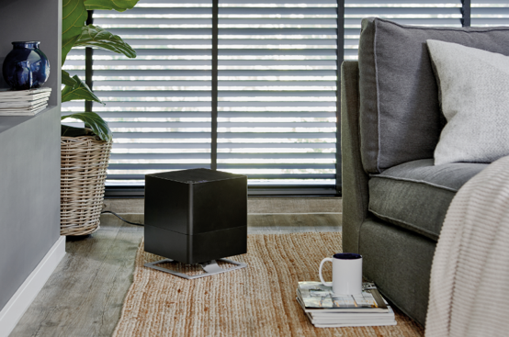

Humidifier Oskar from Stadler Form, in white, black or titanium, current webshop price
from Fr. 139.-
Humidifier Oskar little from Stadler Form, in white, black or titanium, current webshop price from Fr. 69.-
Humidifier Oskar big from Stadler Form, in white or black, current webshop pric efrom Fr. 199.-

Karl and Karl big: high performance, low consumption

Cold weather can strongly decrease the indoor air quality, not only at home but also at the office. Dry eyes, irritated airways and a reduced ability to concentrate are often the result of dry air. Karl and Karl big from Stadler Form are particularly useful in larger rooms, whether at the office or at home. They impress with their elegant design, anthracite-coloured textile covering, high performance and low power consumption.
What are the benefits of Karl and Karl big?

- Precise humidity control: thanks to the auto mode, the humidification output is automatically and efficiently regulated to quickly reach and maintain the desired humidity level.
- Energy efficiency: Karl and Karl big excel in delivering high performance while maintaining low power consumption. They were awarded the Red Dot Award “Best of the Best” in 2023 for their outstanding design, innovative functions and energy efficiency, among other things.
- User-friendly operation: the water container can be conveniently filled via a flap opening even during operation.
- Smartphone app control: all functions can be controlled using the Stadler Form smartphone app.
Where can they be used?

- Room size: Karl is suitable for rooms up to 100 m², while Karl big can even cover areas up to 150 m².
- Where to use: both are ideal for larger rooms such as living rooms and offices because, thanks to their high performance, they can also humidify several rooms at the same time.
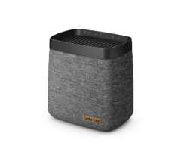
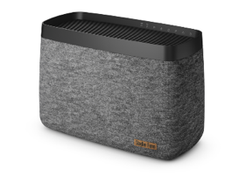
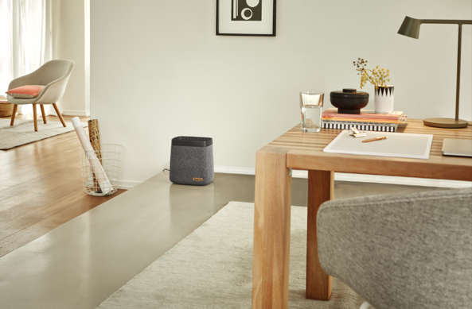

Humidifier Karl from Stadler Form, current webshop price Fr. 229.-
Humidifier Karl big from Stadler Form, current webshop price Fr. 349.-

George: the allrounder

A lack of humidity is not the only factor that can affect air quality. In the autumn and winter months, the air inside homes can become more polluted with fine dust particles due to less frequent ventilation. This can be particularly challenging for people suffering from allergies.
George from Stadler Form offers the ideal solution: as a real all-rounder, George humidifies and purifies the air simultaneously, ensuring a healthy indoor climate.
What are the benefits of George?

- Humidification and air purification: George's rotating discs reliably remove particles, fine dust and unpleasant odours. This function is particularly beneficial for anyone who suffers from allergies, as it also effectively filters allergens out of the air.
- Humidity control: in winter, George regulates the dry air caused by heating and ensures a comfortable humidity level thanks to his powerful performance. The auto mode with integrated hygrostat automatically selects the humidification level to work efficiently and save energy.
- Easy cleaning and use of essential oils: the water base and disc pack can be easily cleaned in the dishwasher. In addition, essential oils can be added to the fragrance container to create a relaxing atmosphere.

Where can he be used?

- Room size: George is suitable for living and working spaces up to 60 m².
- Where to use: ideal for rooms where both humidification and purification are needed.
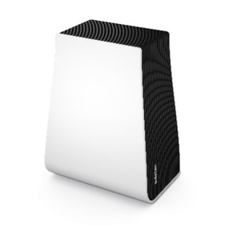
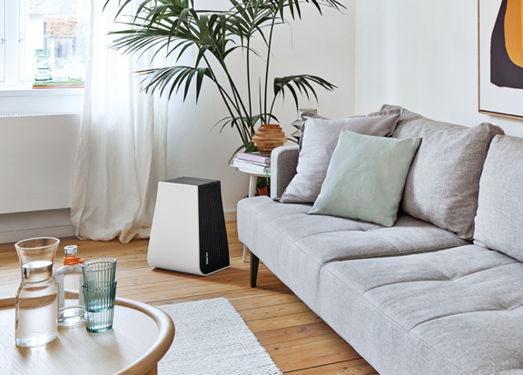
Air washer George from Stadler Form, current webshop price Fr. 249.-

The humidifiers Oskar, Oskar little, Oskar big, Karl, Karl big and the air washer George from
Stadler Form are available on stadlerform.com and in selected specialist shops and their online shops.
Please do not hesitate to contact us for further information.
Press contact

Silvia Acerra
Flowcube Communications | E-Mail: silvia.acerra@flowcube.ch | Tel. +41 (0)43 344 30 35

