PRESS RELEASE I Autumn 2021

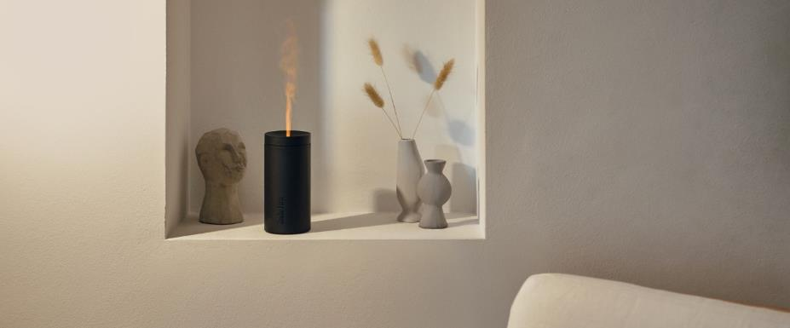
Enlightenment for all the senses

Stadler Form presents aroma diffuser Lucy with flame effect
The cool and wet autumn is the time to hunker down at home where it’s warm and cosy, especially when it’s illuminated by soft light and filled with a subtle fragrance. Preferably in a quiet and atmospheric ambience like the one that can be created by new aroma diffuser Lucy from Stadler Form. Her atmospheric flame effect and wide choice of aromas make Lucy an indispensable companion on autumn and winter evenings.
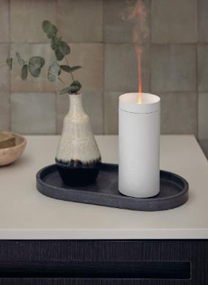
Lucy, «the illuminator», lives up to her name: her Amber LightTM creates a soft candlelight and magical feel-good atmosphere. She creates the perfect mood for a romantic candlelit dinner or a cosy evening in with a book – and is ideal for placing on a beautifully laid table instead of a candle. With her simple design and deceptively realistic candlelight, Lucy can create a pleasant atmosphere for soothing relaxation in any room you like. But Lucy can do a lot more than that: she can fill your room with fragrance. Almost imperceptibly, she disperses a fine mist of essential oils. The secret of her silent art of fragrancing: the finest mist of water – produced by a membrane that moves with ultrasonic velocity.

It is not only her simple design but also her cleverness that make diffuser lady Lucy a winner: thanks to a battery runtime of up to seven hours and a USB cable, the aroma diffuser can be moved around at any time quite easily. So for the first time, an aroma diffuser from Stadler Form can be operated using a rechargeable battery rather than mains power, making Lucy a technical innovation.
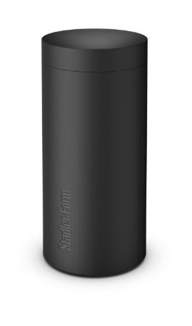

So refined the fragrant mist produced using ultrasonic technology, so easy to use: simply fill with water, add two to three drops of fragrant oil – and you’re done. There are five different natural essential oil mixture from Stadler Form to choose from: Recharge, Relief, Refresh, Relax and Revive. So you can change your fragrance to suit your mood. A feast for the eyes and nose.

Or if you want to enjoy the fragrance without the ambient light, you can dim the light or switch it off altogether, making the smart room accessory ideal for bedrooms too. Eye-catching and able to create a really special ambience without any fuss.

Aroma diffuser Lucy from Stadler Form, current market price, CHF 49.00

Aroma diffuser Lucy from Stadler Form is available at stadlerform.com and from selected specialist stores and their online shops. There are two colours to choose from, white and black.

The 100% natural essential oil mixtures Recharge, Relief, Refresh, Relax and Revive are made in Switzerland and can be purchased separately.

Please do not hesitate to contact us for further information.

Press contact:

Valeria Happel
Flowcube Communications | E-mail: valeria.happel@flowcube.ch | Tel. +41 (0)43 344 30 37

