TRENDLETTER I Autumn/ Winter 2024

Scented gift ideas for every budget

Stadler Form presents five gift ideas for Christmas
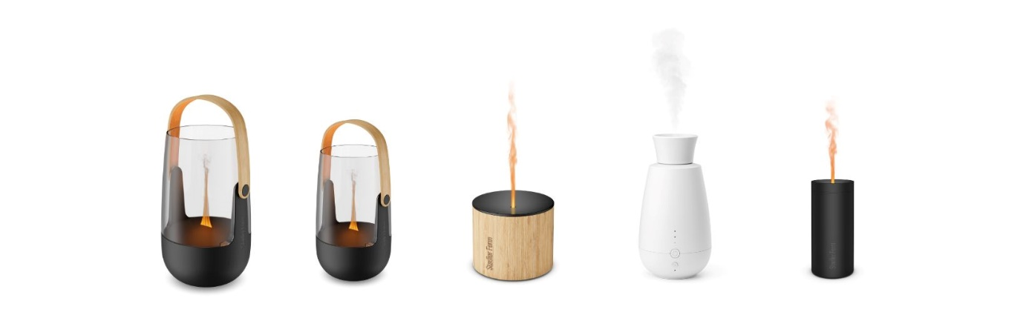
Winter is coming, bringing the quiet Advent season, a time to enjoy peaceful moments. A gentle fragrance fills the room, creating a calming, cosy atmosphere while the snow falls softly outside. The aroma diffusers from Stadler Form help create exactly this feel-good ambience. Sophie, Nora, Ella and Lucy impress with modern technology and stylish design, and together with the matching essential oil, transform every home into a relaxing, fragrant oasis. Whether as a gift for a loved one or for yourself, these roommates from Stadler Form combine functionality and aesthetics. The best thing about them: they are available in a range of prices.

Gift idea <100 CHF: Sophie & Sophie little, the 2-in-1 aroma diffuser and lantern

Sophie and Sophie little from Stadler Form are aroma diffusers and lanterns in one. With their elegant design and natural bamboo handle, they are not only an aesthetic highlight but can also be placed anywhere desired. The warm Amber Light™ creates an atmospheric play of flames, while the ultrasonic technology disperses fragrance almost silently as a fine mist. They are the perfect combination of scent and light, ideal for transforming living spaces or covered terraces into a Christmas wonderland.

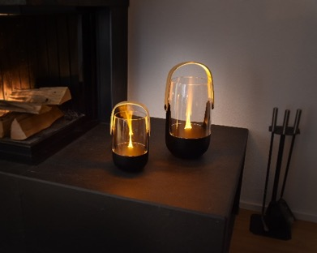
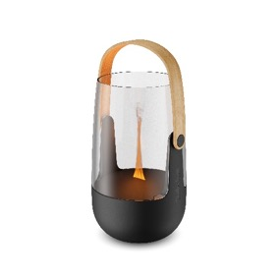
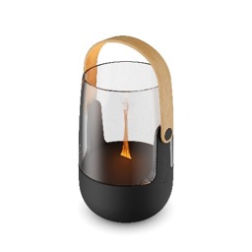

Aroma diffuser Sophie from Stadler Form, current webshop price, Fr. 99.-
Aroma diffuser Sophie little from Stadler Form, current webshop price, Fr. 75.90

Gift idea <80 CHF: Nora, the elegant aroma diffuser lady

Nora combines natural materials of bamboo and high-quality aluminium. Her elegant appearance blends perfectly with festive Christmas decorations and provides a soot-free candlelight atmosphere. Whether for a mulled wine on the balcony or a cup of hot chocolate on the sofa, she is the perfect companion for long winter evenings, both indoors and in covered outside areas . With a battery life of up to 7 hours, Nora will keep you company during long, cosy Christmas celebrations.
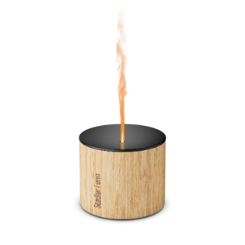
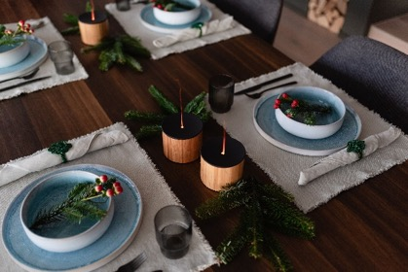

Aroma diffuser Nora from Stadler Form, current webshop price, Fr. 79.-

Gift idea <60 CHF: Ella, the smart fragrance spray system

A fragrant winter wonder: Ella, the smart fragrance spray system from Stadler Form, distributes essential oils directly from the bottle without any water. Her elegant design blends harmoniously into any environment , whether it be in the living room, bedroom or bathroom. Equipped with a light sensor that switches Ella on or off depending on the current light conditions, three intensity levels, and a long battery life of around 10 days, Ella offers maximum flexibility.

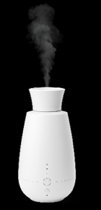
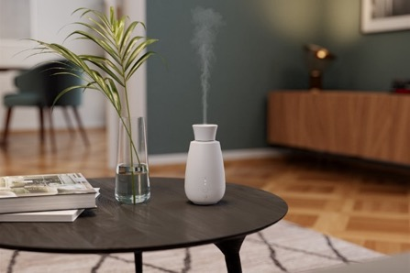

Aroma diffuser Ella from Stadler Form, current webshop price, Fr. 59.-

Gift idea <50 CHF: Lucy, the radiant aroma diffuser lady

The deceptively realistic flame effect makes Lucy an indispensable accessory for frosty winter evenings and the holiday season.She creates a particularly atmospheric effect on a festively decorated table. Lucy bathes the room in a soft light and fills it with a subtle scent, which is distributed by ultrasonic technology as a fine mist of essential oils. As she can be operated by a rechargeable battery, she can be placed anywhere in the house.

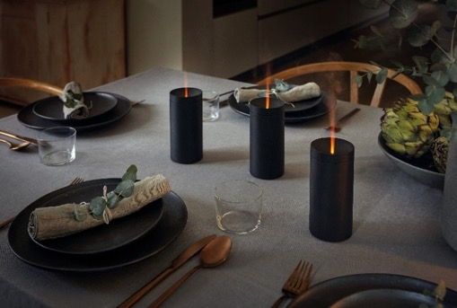
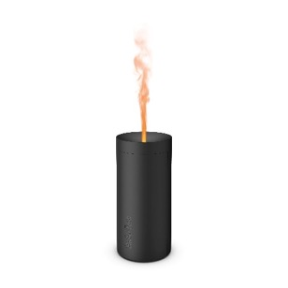

Aroma diffuser Lucy from Stadler Form in Black, White or Gold, current webshop price, Fr. 49.-

Gift idea <10 CHF: Recharge and Retreat, the essential oils to recharge your energy

Holidays can also be stressful, making it even more important to relax during this time. The essential oils from Stadler Form are 100 % pure and sustainably produced. Recharge and Retreat
exude a particularly wintry atmosphere. With notes of fir and pine, Recharge fills the room with a tart scent reminiscent of walks in a snowy forest. Retreat, on the other hand, combines oranges and cloves and has a warming and mood-lifting effect.

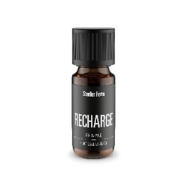
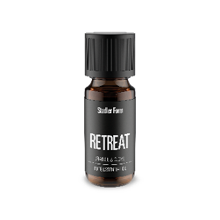
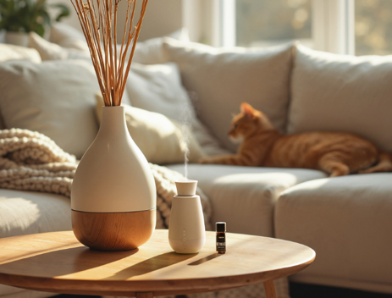

Essential oil Recharge from Stadler Form, current webshop price, Fr. 9.90
Essential oil Retreat von Stadler Form, available from the end of October in the webshop, Fr. 9.90

There is a selection of different natural essential oils and oil blends from Stadler Form to choose from for your gift ideas: Recharge, Refresh, Relax, Relief, Repel, Retreat (from the end of October),
Lavender und Lemon.
Sophie, Nora, Ella, Lucy and the Stadler Form essential oils are available on stadlerform.com and in selected specialist shops and their online shops.
Please do not hesitate to contact us for further information.
Press contact

Silvia Acerra
Flowcube Communications | E-Mail: silvia.acerra@flowcube.ch | Tel. +41 (0)43 344 30 35

