Press release I May 2022

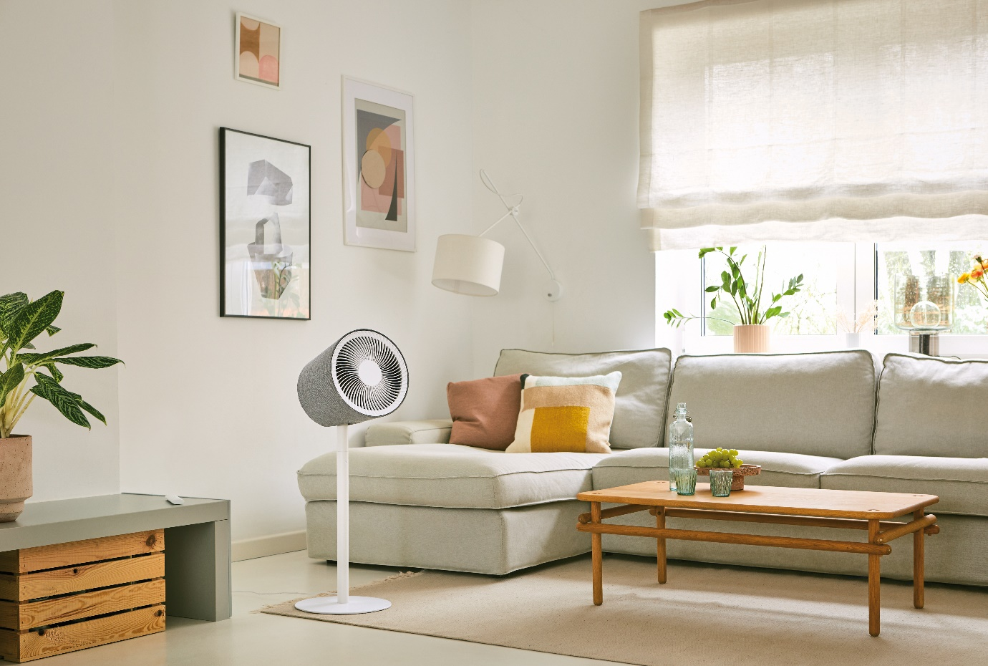
“This design fan will be the new summer hit of 2022”
Product launch: Stadler Form presents Simon, the 3D air circulator
When the temperature rises, the air accumulates indoors and it quickly becomes unbearably stuffy. That's when we long for a cool breeze. Stadler Form is a design brand for air treatment products. Their latest creation is a futuristic 3D air circulator that integrates into the living ambience like an artistic feature, with its minimalist shape and modern textile cladding.

Interior trend: 3D air circulation provides all round freshness, as if by magic

During the warm season, fans become real summer treasures, proving diligent and popular flatmates. And there has been a lot of change in recent years in terms of both design and functionality. Round table fans are regarded as classic old-timers nowadays; large wind distances, stands that provide an ideal cooling height and a natural all round freshness are seen as increasingly important. And modern fans are expected to produce a powerful performance without making too much noise. Timer settings and convenient remote controls are also high on the wish list. Stadler Form has worked in collaboration with Swiss product designers to develop a 3D air circulator that ticks all the technical boxes and is also a timeless eye-catcher.

Stadler Form CEO Martin Stadler explains



What makes Simon so technically special?

“Simon is no ordinary fan; it's a 3D air circulator. That's already a big difference because Simon's 3D swing function allows him to circulate the air throughout the room. As soon as you turn him on, the fan moves horizontally up to 180° and vertically up to 90° in the direction you choose. He looks cool, but he also provides all round air distribution. With a wind distance of 10 meters, Simon is also powerfully refreshing, which is really impressive for a product with such subtle design. Despite the device's powerful performance, it’s also worth noting that it is particularly quiet running. This presented a significant design challenge – solved with considerable technical expertise. The extraordinary and varied functionality is what makes Simon so special.”

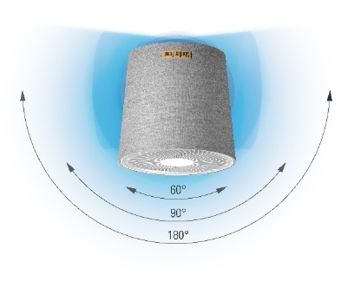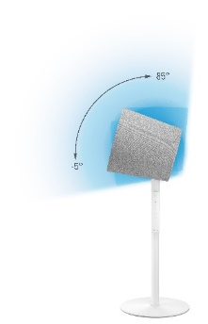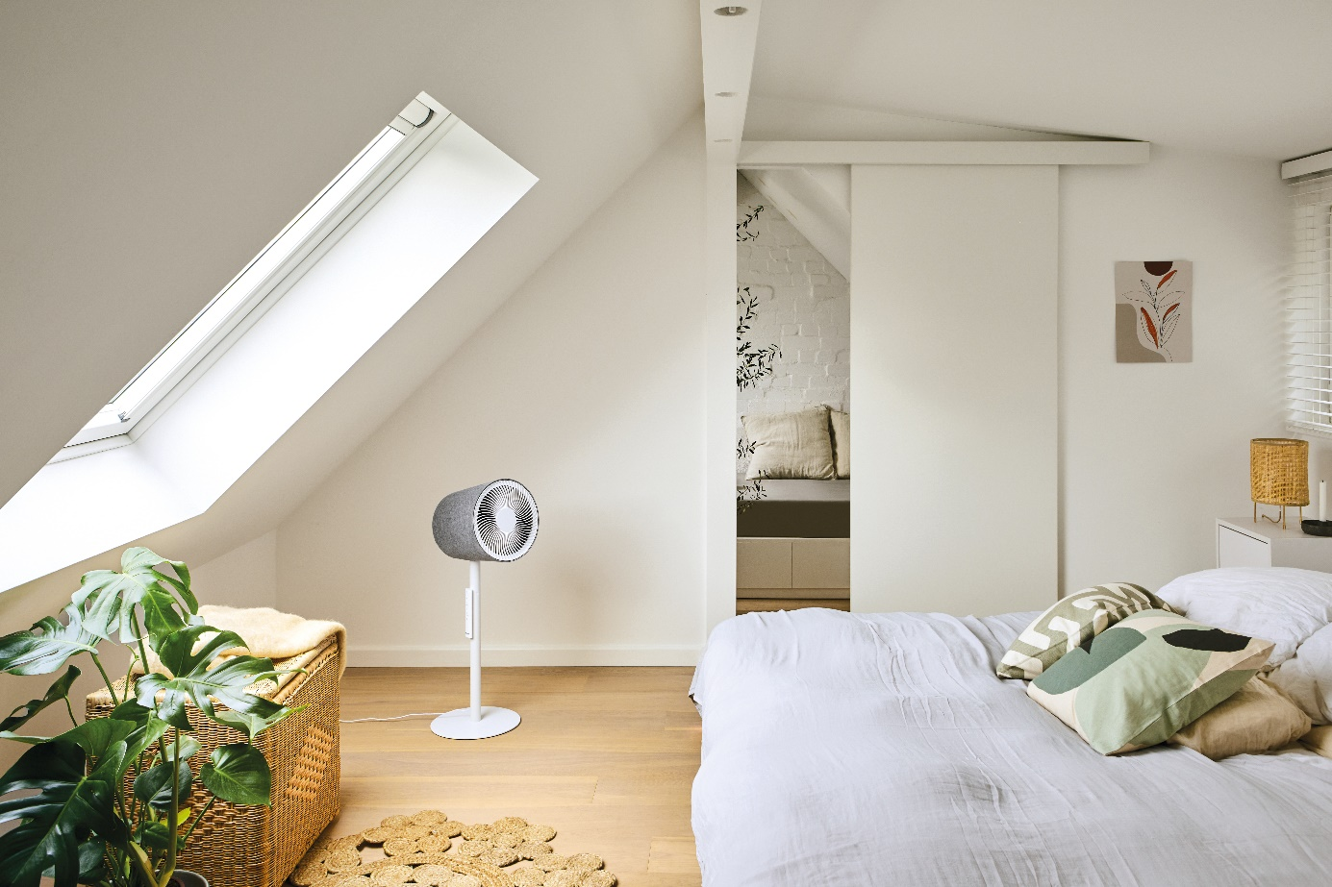

How does a modern fan build a fan base?

“Alongside the technical demands – high performance, a 3D swing function and a large wind distance – convenience is also very important. So a 1–7 hour timer allows Simon to switch himself off automatically after a set number of hours. If you want to change a setting, it’s possible from the comfort of your sofa with a magnetic remote control. A fan also needs to be clever enough to respond to individual needs. So Simon offers 10 speed levels, ranging from a cool breeze to a strong wind. Natural wind conditions can also be simulated in the Natural Breeze Mode.”

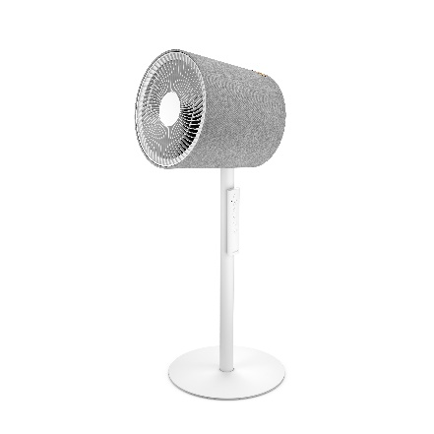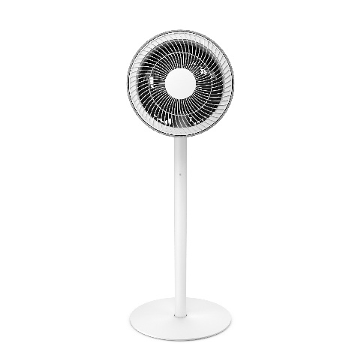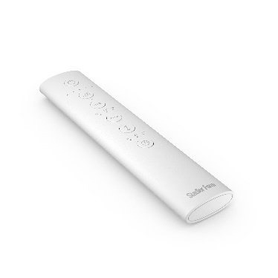

On-trend textile cladding. What’s all the fuss about this design idea?

“Interior textile claddings are immensely exciting as a design feature. Paradoxically, we want our devices to really catch the eye with their high-quality material – but we also want them to blend into living areas perfectly, so they are all but invisible. That's where the art comes in. Design is art. It makes the new 3D fan an artistic feature within your own four walls. Simon skilfully combines function with aesthetics. And so I’m sure of one thing: this design fan will be the new summer hit of 2022.”

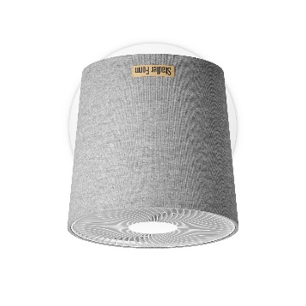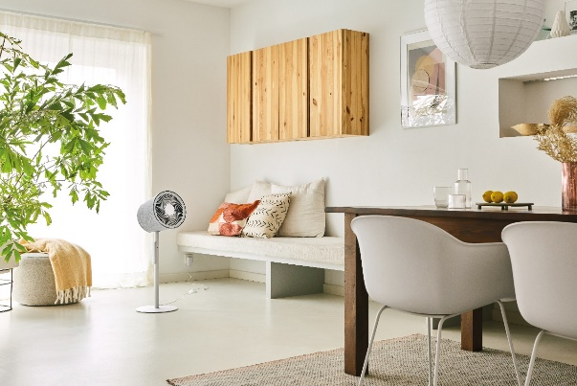

3D air circulator Simon from Stadler Form, current webshop price CHF 239.–

The Simon fan from Stadler Form is available from 3 May 2022 at stadlerform.com and in selected specialist shops or their webshops.

If you would like to know more, please contact us.

Media contact:

Valeria Happel
Flowcube Communications | E-mail: valeria.happel@flowcube.ch | Tel. +41 (0)43 344 30 37

