PRESS RELEASE I October 2024

Cosy warmth or pleasant refreshment
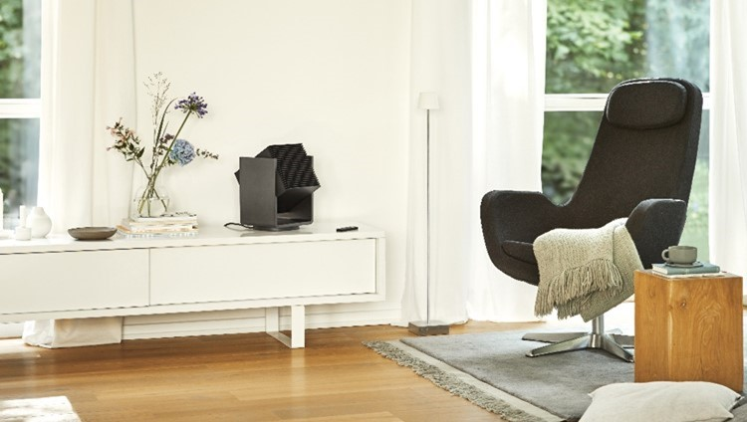
Stadler Form presents the smart 2-in-1 heater and fan Alex
If the temperature inside your own four walls is too low, you freeze; if it's too hot indoors, you quickly start sweating. Both are unpleasant and disrupt sleep and concentration. The room temperature is crucial for your own well-being. Fan heaters and fans can play a decisive role as helpers. On 29 October, Stadler Form is launching an all-rounder that ensures pleasant living conditions all year round. Alex is the first 2-in-1 heater and fan from Stadler Form that can either provide cooling or heat to the exact degree.
«We are delighted to present Alex, an ideal companion for the whole year. In collaboration with Swiss product designer Matti Walker, it was important to us to develop a device that combines the functions of a fan and a fan heater without compromising on performance or design. Alex has smart functions and blends in with any interior design thanks to his elegant appearance», explains Stadler Form CEO Martin Stadler.
The following features make Alex from Stadler Form the perfect roommate:
- All-round refreshment and precise heating
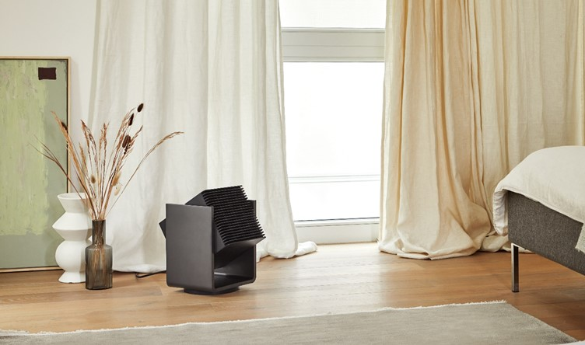
No matter what temperature the thermometer shows outside, Alex always ensures a pleasant feeling in the respective living area. In heating mode, two heat settings and the digital thermostat enable precise heating. In fan mode, Alex has four speed levels: from a very quiet and gentle breeze to a strong wind. Alex is mobile, requires little floor space and can be positioned in a wide variety of places in the home, both on a sideboard and on the floor. So he can be used anywhere and at any time. With his range of up to eight meters, he provides cooling in summer and soothing warmth in winter.
- 3D oscillation for ideal air distribution
Alex's 3D oscillation ensures uniform air distribution indoors in both modes – as a heater and fan. He automatically oscillates up and down and from left to right. Depending on the setting, Alex can distribute the air flow only horizontally, only vertically or both simultaneously. With a wind distance of up to eight meters, the air reaches everyone in the room.

- Controllable from anywhere via Wi-Fi
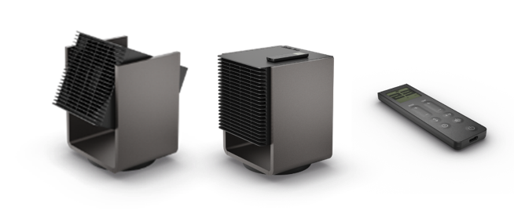
Alex can be controlled either via the wireless remote control, which also functions as a digital display and can be magnetically attached to him, or via the Stadler Form app using Wi-Fi. This means Alex can also be operated while on the go, and you don't have to do without any of his functions: all features, such as the digital thermostat, with which you can select a desired temperature from 5 °C to 34 °C or continuous operation, can be set in the user-friendly app.

Alex from Stadler Form, colour titanium, current webshop price, Fr. 249.-

Alex from Stadler Form is available from the 29 October 2024 on stadlerform.com and in selected specialist stores as well as their online shops.

Please do not hesitate to contact us for further information.

Press contact

Silvia Acerra
Flowcube Communications AG | E-Mail: silvia.acerra@flowcube.ch | Tel. +41 (0)43 344 30 35

