TREND LETTER I Spring 2021
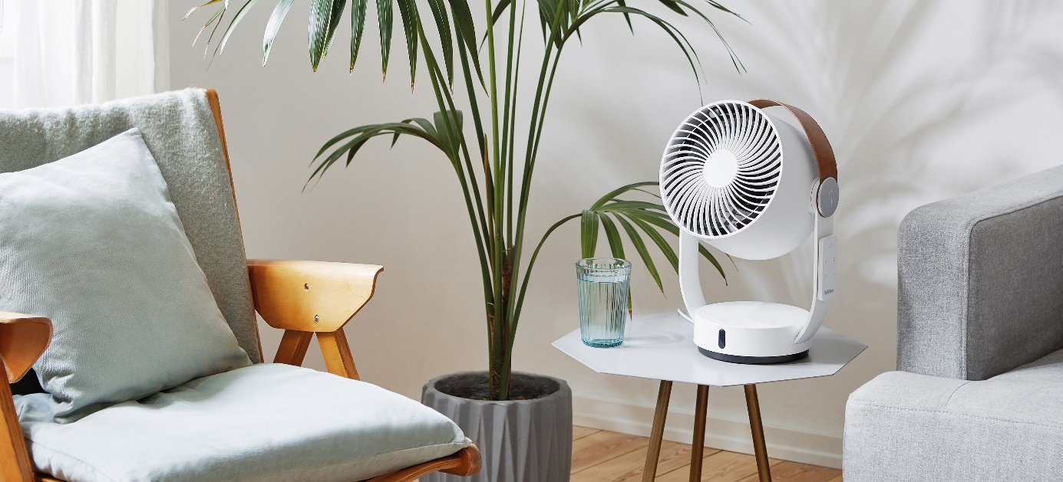

Innovative all-round refreshment and a fashionable spotlight look
Stadler Form presents 3D fan Leo with a wide range of 8 metres
When temperatures rise outside and it starts to get hotter indoors, it’s not long before all you can think about is a cooling breeze. On 15 April, Stadler Form – a brand renowned for intelligent air solutions – launched a new product: fan Leo has the look of a contemporary spotlight and his innovative 3D oscillation ensures all-round refreshment.

New 3D air circulation experience

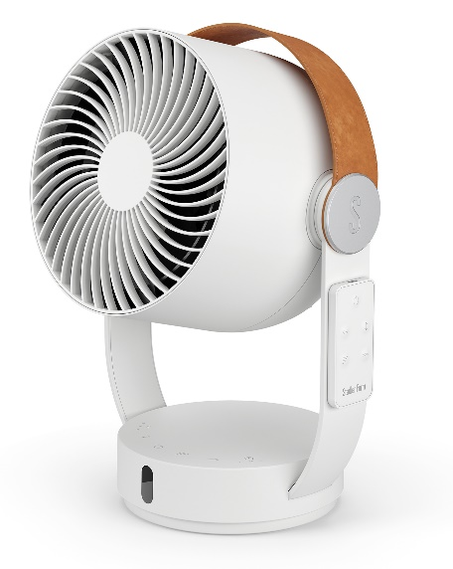
Leo from Stadler Form circulates the air flow in the room not just horizontally but vertically too, providing three-dimensional all-round refreshment with his innovative 3D oscillation.

With a range of 8 metres, Leo from Stadler Form can refresh everyone in the room and also provides optimum cooling for sporting activities. There are four different speed settings to choose from – and you can set them quite easily using the practical remote control which is magnetically attached to Leo.

You can also choose how far you want Leo to swing to the right or to the left as he has three individual angle settings: 60°, 90° or 180°. The smaller the angle you choose, the more often a part of the room or a particular person will experience the wind that Leo produces. On the highest setting, he simulates strong gusts of wind so that if you close your eyes, you can imagine yourself lying on a beach somewhere. Or you can enjoy a refreshing breeze while you are doing your yoga exercises, for example. A 1-7 hour timer allows you to decide how long you want Leo to provide refreshment.

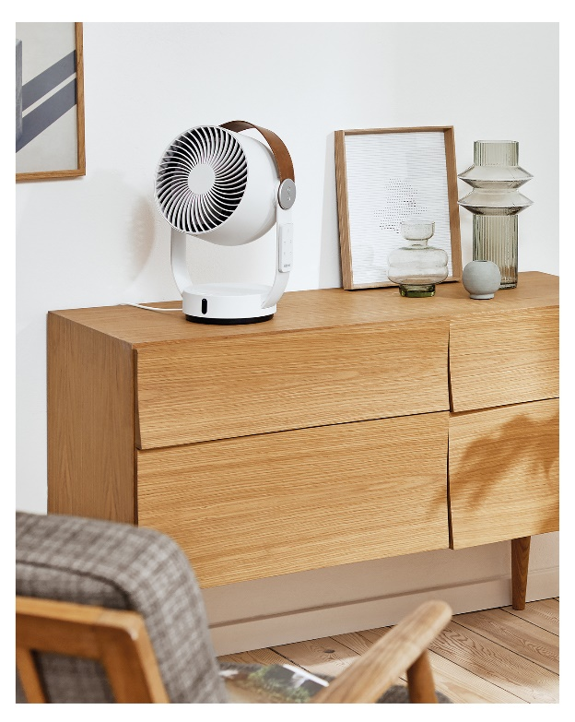
Swiss design object is a real eye-catcher

With his stylistic confidence, as soon as Leo from Stadler Form has found a spot for himself, he become a valued important member of the family right away, quietly circulating the wind he produces in all directions.

The unique design of the 3D fan has the look of a contemporary spotlight while a practical faux leather carrying handle makes Leo easy to move around.

Leo was designed by Swiss design duo Bernhard & Burkard in partnership with Stadler Form.

3D fan Leo from Stadler Form, RRP Fr. 119.00

You can see all the functions in the video here.

3D fan from Stadler Form will be available from 15 April via stadlerform.com and in selected specialist stores as well as their online shops.

Download images

Please do not hesitate to contact us for further information.

Press contact:
Valeria Happel
Flowcube Communications | E-mail: valeria.happel@flowcube.ch | Tel. +41 (0)43 344 30 37

