TREND LETTER I Spring 2022

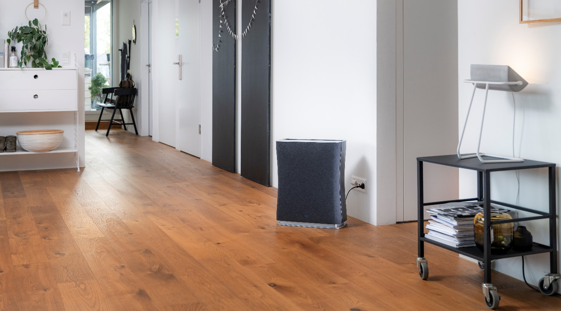
This home accessory combats pollen and ensures good air quality
Hero of the hour: air purifier Roger from Stadler Form in an elegant fabric design
Spring has sprung. Pollen flying around in the air and fine dust are the reason for our itchy eyes, runny noses and asthma. Stadler Form is a Swiss design brand for indoor air conditioners and its stylish product provides the perfect solution: smart housemate Roger can help allergy sufferers breathe easily again within their own four walls in no time at all. But non-allergy sufferers can also benefit from good air quality as when set to Auto mode, Roger also removes unpleasant odours, gases, bacteria and viruses from the air. As a result, he can create an oasis of well-being at the press of a button.

Longer pollen season in Switzerland

Irritating symptoms can last until September depending on the type of allergy you have, making Roger the perfect companion during the warm months of the year. Studies show that around 20 per cent of the Swiss population suffer from a pollen allergy. Itchy eyes, runny noses and also shortness of breath are symptoms that can torment sufferers for weeks. Due to climate change, not only is the pollen season now longer but it also starts two to three weeks earlier than it used to a few years ago. Meteonews Switzerland reported the first recorded pollen count for this year back in January. If you suffer from allergic reactions, you are recommended to sleep with the windows closed, not to dry washing outdoors and to wash your hair regularly, for example. However, you only have to go for a short walk for pollen to stick to your clothes so that you bring it back home with you. Based on intensive research and collaboration with Swiss product designers, Stadler Form has created an air purifier that can bring relief at the press of a button.

Swiss model Vivienne Oesch relies on Roger little

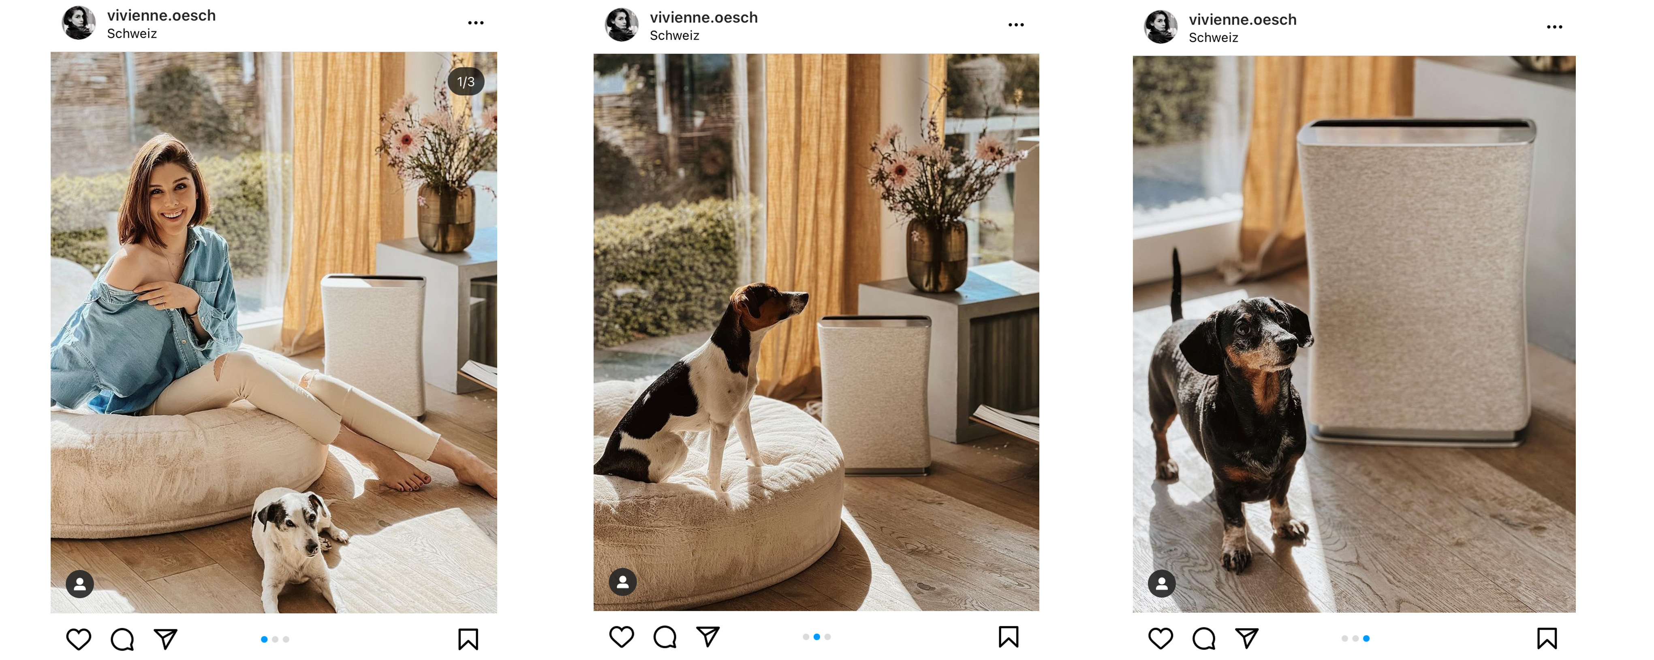
«My partner as well as some of my relatives suffer from a pollen allergy. Because of that, it is a subject that is very important to me and one that I have to deal with on a daily basis. For me, Roger little is a true hero. Since setting him up in my living room, none of our household have had any symptoms to cope with any more. Allergies are very common so our guests appreciate the good air quality too. The fact that Roger little removes kitchen smells too is an added bonus. All in all, my new housemate has helped to create a wonderful feel-good atmosphere. And with his elegant design and high-quality fabric cover, he fits in perfectly with my interior style», says Vivienne Oesch, a Swiss model and influencer.

Click here for the post

Housemate combats pollen independently

The air indoors is five times more polluted than the air outdoors and we breathe in up to 12,000 litres of air a day. Roger from Stadler Form changes the air in rooms of up to 66 m² three times an hour. Thanks to his specially designed Dual Filter consisting of a HEPA filter and an activated carbon filter, he can remove pollen, fine dust, gases, odours, bacteria and viruses from the air. Clean air brings numerous benefits:

- Improved concentration
- Reduced fatigue
- Deeper sleep
- Better regeneration
- Alleviates symptoms of allergies such as pollen, animal hair and dust mites
- Reduces the risk of transmission of pathogens

As soon as the LED light behind the elegant fabric cover comes on, it means that you have good quality air. If the light is orange or even red, then your air quality is poor. The highlight with Roger is that he adjusts the power setting himself in Auto mode in order to purify the air quickly in his own energy-efficient way. Should you wish to change the setting yourself, you can also control your clever housemate quite easily from your sofa or when you are out and about using your smartphone.

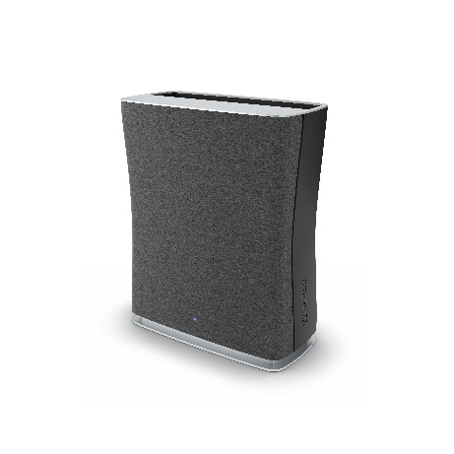

Roger from Stadler Form is available in 3 sizes:

Air purifier Roger little from Stadler Form for rooms of up to 33 m², current webshop price Fr. 228.-
Air purifier Roger big from Stadler Form for rooms of up to 104 m², current webshop price Fr. 499.90.-
Air purifier Roger from Stadler Form for rooms of up to 66 m², current webshop price Fr. 306.-

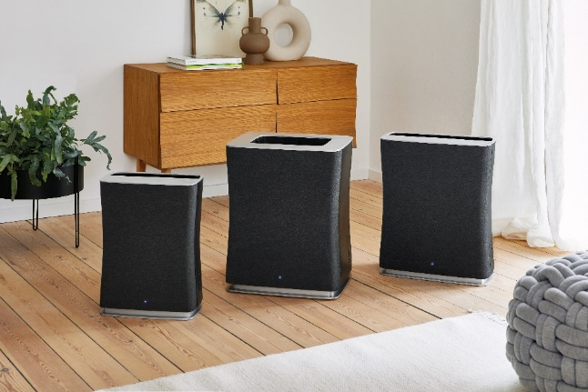

For more information on the subject of «Healthy air», click here.

Air purifier Roger from Stadler Form is available via stadlerform.com and in selected specialist stores as well as their online shops.

Please do not hesitate to contact us for further information.

Press contact:

Valeria Happel
Flowcube Communications | E-mail: valeria.happel@flowcube.ch | Tel. +41 (0)43 344 30 37

