PRESS RELEASE I September 2023

Cosy and warm

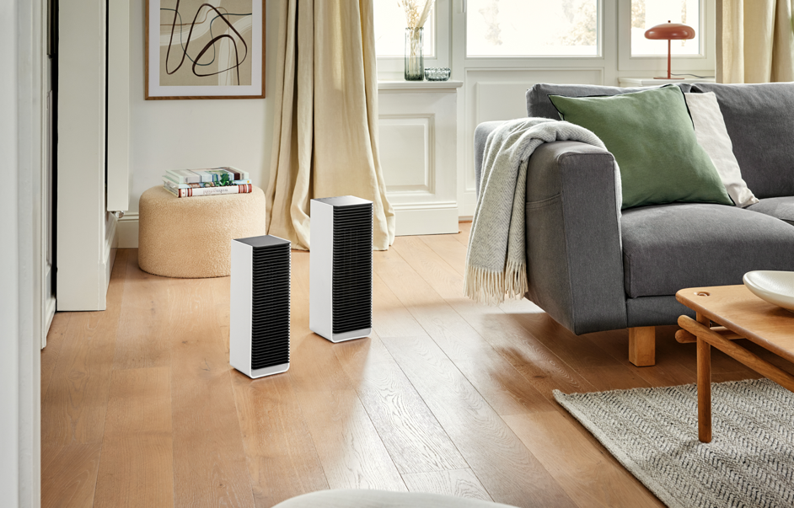
Product launch: Stadler Form presents the elegant fan heaters Sam and Sam little

In mid-season the central heating is often not yet on or has already been switched off and the interior spaces are not sufficiently heated by the outside temperatures. As a result, we’re freezing. Our hands and feet are usually the first parts of our body to feel the cold. Fan heaters offer a simple, quick solution, providing cosy heat exactly where you need it. This autumn, Stadler Form will be expanding its product range and launching two elegant roommates on 5 September: Sam and Sam little. The larger one impresses with Wi-Fi connectivity as well as a digital thermostat and the smaller one with his slim design.

Stadler Form, in collaboration with Swiss product designer Matti Walker, developed two fan heaters that not only meet all technical requirements but are also timeless eye-catchers. With their modern design the new roommates will blend in with any interior ambience.

Sam: precise and smart

Rooms that you sit in for long periods of time can quickly get cold. When the central heating is not enough, a fan heater can ensure a pleasant room temperature. Sam is the fan heater for high-precision heating. Thanks to his Adaptive Heat™ technology, he controls the heat output independently, reaching the desired temperature quickly and then maintaining it automatically. Sam’s key feature? Due to his Wi-Fi functionality, he can be controlled from anywhere. Whether you are relaxing comfortably on the sofa at home or you are still on the go and want to preheat the living room. The newcomer from Stadler Form has four power settings to choose from so that he can adapt to individual requirements and provide heat where it is needed.

Sam little: space-saving and energy-efficient

In smaller rooms of up to 20 m², Sam little from Stadler Form has two power settings for creating a pleasant atmosphere. You might need more heat in the children’s room or at the changing table to keep your little ones warm, for example. Thanks to his slim design and compact size, Sam little is particularly space-saving. The desired temperature can be set quite easily using a rotary controller.

Stadler Form CEO Martin Stadler explains



What makes Sam and Sam little so special?

«Besides technical requirements – such as energy-efficient performance and high-precision heating – convenience also plays an important role. Nowadays, a heater needs to be clever and be able to adapt to individual needs. That is why we developed two models with different features in collaboration with designer Matti Walker. Sam is the smart fan heater, equipped with technical functions such as control via Wi-Fi, a digital thermostat for precise heating and independent temperature control thanks to his Auto mode. The smaller roommate – Sam little – is compact and can be carried from one room to another, making him perfect for smaller rooms too.»

How do you operate Sam and Sam little?

«Fan heater Sam has a digital thermostat that is responsible for setting the temperature. Sam can be operated easily and conveniently using a touch panel or the Stadler Form app via Wi-Fi. In Auto mode, he will then take care of everything else independently. Sam little is equipped with an integrated thermostat so that the desired temperature can be set individually. As soon as the target temperature is reached, both fan heaters switch off automatically. If the temperature drops below the desired level, they heat up again.»
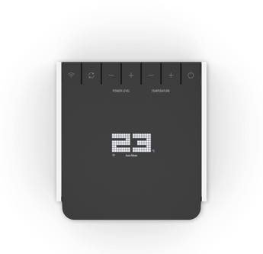
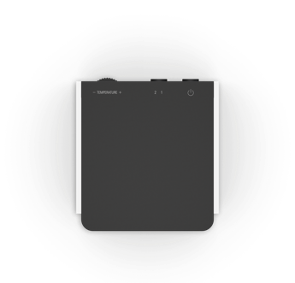

How safe are the new fan heaters?

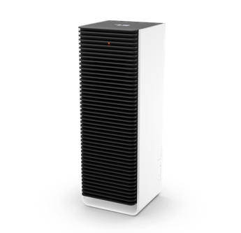
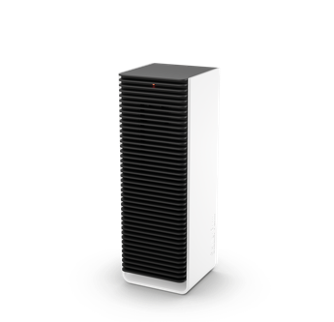
«With both newcomers, safety is the top priority. The models are equipped with tilt and overheating protection, ensuring maximum safety in any room – including children’s rooms.»

Sam, Stadler Form, current webshop price, CHF 129.-
Sam little, Stadler Form, current webshop price, CHF 89.-

Fan heaters Sam and Sam little from Stadler Form will be available from 5 September 2023 via stadlerform.com and in selected specialist stores as well as their online shops.

Please do not hesitate to contact us for further information.

Press contact

Silvia Acerra
Flowcube Communications | E-mail: silvia.acerra@flowcube.ch | Tel. +41 (0)43 344 30 35

