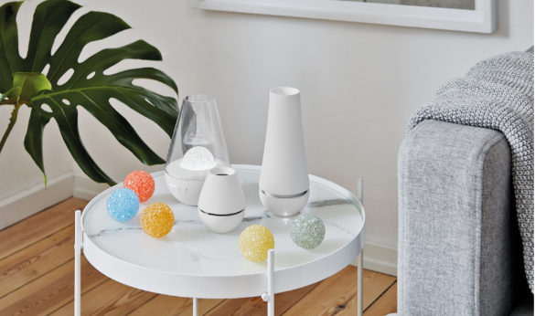
PRESS RELEASE I October 2021

Innovative trio: savvy room freshness

Stadler Form presents aroma diffusers Nina, Lina and Tina in elegant white

When the days get shorter and the temperature starts to drop, it’s time for some pampering. Add candles, scatter cushions and autumnal decor to turn your home into a feel-good oasis. But don’t just make it warm, cosy and romantic: make it smell good too. Stadler Form is launching its new fragrancing trio: aroma diffusers Nina, Lina and Tina all work without water and there is no need to add fragrance oils either. Their secret: an innovative fragrance globe system that is easy to use and emits a long-lasting aroma.

Through collaboration with Swiss product designers, Stadler Form has developed a sophisticated system for unique, futuristic aroma diffusers Nina, Lina and Tina – and so it will be launching three technical innovations in autumn 2021. There are a total of six fragrances to choose from: White Amber, Yellow Vanilla, Orange Bergamot, Red Jasmine, Black Orchid and Blue Rosewood. The fragrance globes are made from bonded fragrance pearls enriched with an intense aroma which lasts for up to four weeks. But best of all: no matter how often you move the trio, thanks to the innovative system you can rest assured that you won’t have any leaks.

The atmospheric one: Nina from Stadler Form for large rooms
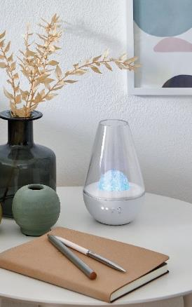
Nina is the perfect choice if you want your home to smell good as well as look good. Not only does she emit a pleasant aroma, she also creates an atmospheric ambience thanks to her fragrance globe. You can dim the light or switch it off altogether according to your mood, and also regulate the fragrance if you wish: there are two levels to choose from so that you can create a softer or more intense aroma. As with all three sisters, there are six types of fragrance globe to choose from and when used with the transparent Nina, they light up in different colours. And then all you have to do is relax and enjoy for at least four weeks. Nina is also suitable for larger rooms such as lounges or bedrooms and comes with a battery that lasts for up to 50 hours and a USB cable. Lovely and bright!

Aroma diffuser Nina from Stadler Form, current market price, CHF 79.00

The uncomplicated one: Lina from Stadler Form for wardrobes

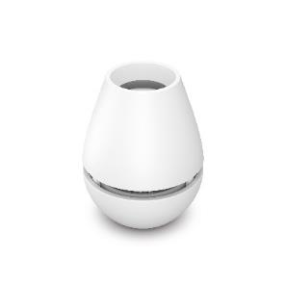
Lina is impressively simple and uncomplicated. She needs no power, making her perfect for providing fresh air in a closet or wardrobe. The smallest of the bunch is incredibly easy to use: simply pop in a fragrance globe and turn the cover to create your desired fragrance intensity or – for a particularly intense aroma – take it off altogether. At just 8 cm, her handy size means that Lina will fit into any corner, however small. Small but powerful!

Aroma diffuser Lina from Stadler Form, current market price,
CHF 19.90

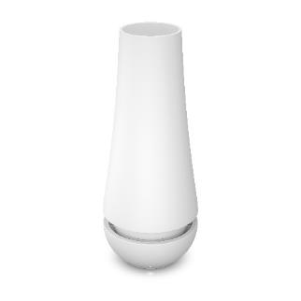
The slim one: Tina from Stadler Form for small rooms

Tina has a captivating elegance about her but also has inner qualities that are certainly worth talking about. Adjust the fragrance intensity in an instant, simply by turning the top part slightly: the more you turn it, the stronger the fragrance that your fragrance globe – you also have six different aromas to choose from – will emit for up to four weeks. While Tina has a battery that lasts for up to 30 hours, she also has a USB connection so that this aroma diffuser can be used without a battery, anytime and anywhere. With her respectable yet still dainty height of just under 18 cm, Tina will look good in the corner of any room.

Aroma diffuser Tina from Stadler Form, current market price, CHF 59.00

All three aroma diffusers from Stadler Form come with the White Amber fragrance globe. Other aromas can be purchased separately.

The aroma diffuser trio from Stadler Form is available from 18 October at stadlerform.com and from selected specialist stores and their online shops.

Please do not hesitate to contact us for further information.

Press contact:
Valeria Happel
Flowcube Communications | E-mail: valeria.happel@flowcube.ch | Tel. +41 (0)43 344 30 37

