PRESS RELEASE I October 2024

Mobile, smart and powerful

Stadler Form launches Ella, a fragrance spray system for feel-good moments

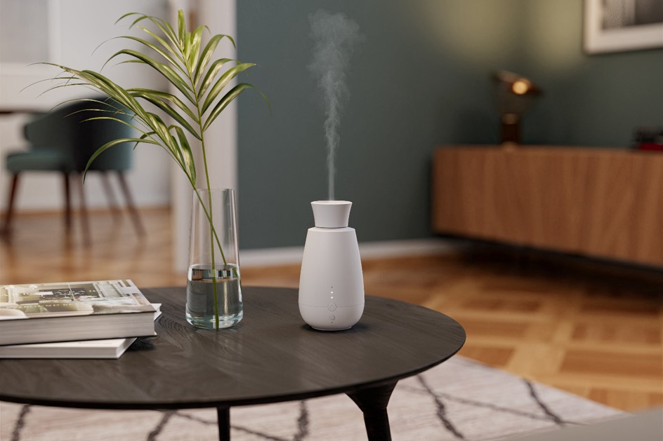

A fragrant home creates an inviting atmosphere that relieves the stress of everyday life and relaxes body and mind. On 1. October 2024, Stadler Form launches Ella, an innovative fragrance spray system that diffuses essential oils directly from the bottle and without water. Whether in the living room, bedroom or bathroom – Ella provides an intense and natural fragrance experience and blends stylishly into any environment. Thanks to the integrated light sensor, the three intensity levels and the long battery life, Ella can be used flexibly in any room and adapts effortlessly to different everyday situations.

“We are delighted to introduce Ella as the latest addition to our Aroma Diffuser range. In collaboration with designers Fabian Bernhard and Thomas Burkard, we have developed Ella, an elegant and intelligent aroma diffuser lady designed for anyone looking for a practical and intense fragrance spray system. She impresses with her super easy handling, long battery life and intelligent functions that make her a useful and quiet roommate,” explains Martin Stadler, CEO of Stadler Form.

The following highlights make Ella from Stadler Form an ideal accessory with a lot of fragrance power:

1) A pure fragrance experience without compromise

Ella provides an intense fragrance experience by spraying essential oils directly from the bottle without water. The oils are distributed as a fine mist of micro-particles, leaving the natural essence of the essential oil unadulterated and guaranteeing an authentic fragrance experience.

2) Flexible fragrance intensity and easy handling

Ella transforms every room into an oasis of well-being. With three intensity levels, the fragrance can be customised to suit your mood. At the lowest intensity level, Ella sprays the scented oil every 5 minutes for 5 seconds, at the second level every 3 minutes for 5 seconds and at the third level every minute for 10 seconds for an intense experience. Handling is intuitive and easy: insert the essential oil bottle into the spray head, switch on Ella and she will diffuse your favourite fragrance. Changing the fragrance is also very simple: she is compatible with fragrance oil bottles in the sizes 5 ml, 10 ml and 15 ml. If your own fragrance oil is too big, you can easily fill the desired fragrance in the empty bottle supplied and enjoy it intensively.

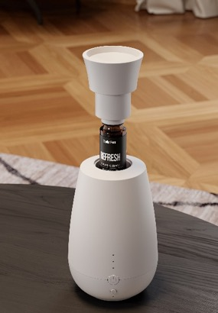

3) Flexible use thanks to long-lasting battery power

A gentle hint of lavender in the bedroom, a refreshing citrus note in the bathroom or the soothing scent of wild fir in the living room: Ella's integrated rechargeable battery enables mobile and cordless use throughout the home. With a battery life of around 10 days on the lowest setting, she offers a long-lasting fragrance experience and will quickly become your favourite accessory.

4) Smart light sensor for personalised use

Thanks to the integrated light sensor, the new product from Stadler Form also adapts to the lighting conditions: In this mode, Ella is only activated when it is bright. In dark rooms or at night, she switches off automatically, which is particularly practical for guest bathrooms or rooms where automatic fragrance diffusion is only required during the day. This also extends the battery life. Also practical for the night: the LEDs can be switched off for undisturbed sleep.
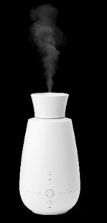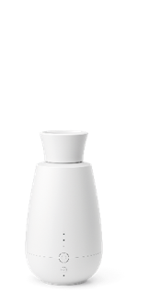

Ella from Stadler Form, current webshop price, Fr. 59.-

Natural fragrance variety

All aroma diffusers from Stadler Form, including Ella, unfold their full potential in combination with pure natural essential oils. High-quality, sustainably produced and free from synthetic substances, parabens and pesticides: This is how Stadler Form's natural essential oils and oil blends are characterised.
The two novelties launched this summer create a refreshing and inviting atmosphere:

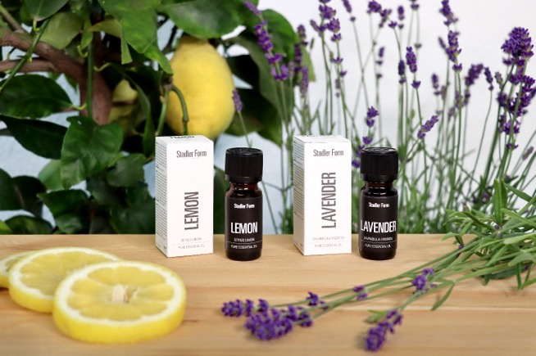

Lavender: This lavender essential oil has a calming and balancing effect. Made from high-quality lavender plant essences, Lavender offers a pleasant floral fragrance and provides relaxation.

Lemon: Lemon oil refreshes and revitalises the senses. The tangy and invigorating scent of lemon brings freshness to any room and provides an energising effect.

In addition to the two new fragrance oils, Stadler Form offers five more to choose from: Recharge, Relief, Refresh, Relax and Repel.

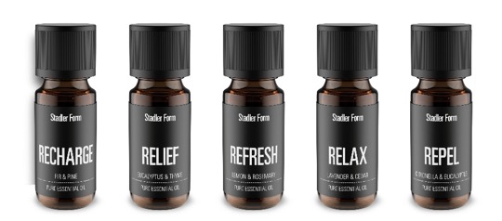

Essential oils from Stadler Form, current webshop price, Fr. 9.90

Ella by Stadler Form is available from 1. October 2024 on stadlerform.com, in selected specialist shops and their online shops.

Please do not hesitate to contact us for further information.

Media contact

Silvia Acerra
Flowcube Communications AG | E-Mail: silvia.acerra@flowcube.ch | Tel. +41 (0)43 344 30 35

