TREND LETTER I Summer & Autumn 2021
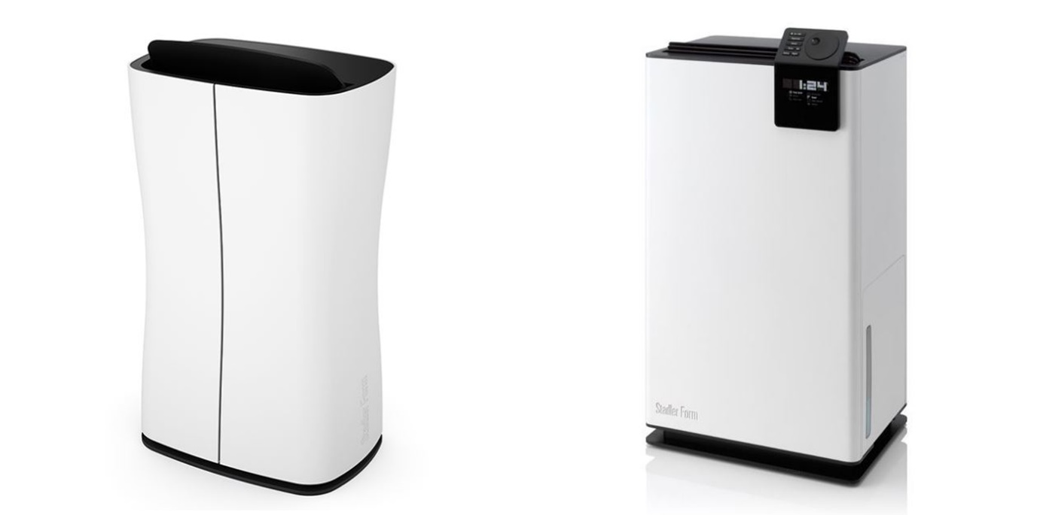

Theo and Albert ensure good air quality in summer and autumn
Stadler Form presents two designer dehumidifiers that follow the 2021 trend towards Green Living
Green Living is the design trend for 2021. Houseplants – both large and small – can turn your home into a green oasis. However, they do have an undesirable side-effect: houseplants that need a lot of water release it back into the atmosphere, thereby increasing the humidity indoors. Stadler Form – a brand for intelligent air solutions – presents two products that provide an immediate remedy: slim dehumidifier Theo and powerful dehumidifier Albert. Theo can bring the level of humidity back down quickly and efficiently and his practical carrying handle means that he can be set up wherever you need him quite easily. The ingenious Albert ensures that the air humidity never increases in the first place while his swing function circulates the indoor air.
Theo – the stylish dehumidifier

While disguised as a minimalist and simple design object, Theo efficiently extracts excess moisture from the air. An integrated hygrostat means the desired humidity can be set within the recommended range between 40% and 60%. Theo’s timer can be programmed for an operating period of 1-7 hours, enabling him to do his job independently. As soon as the period of time finishes or the water tank is full, Theo switches off automatically. Even if Theo is left home alone for longer periods, there is no question of the tank overflowing thanks to the drainage hose also supplied. His slim stature and practical carrying handle make the stylish dehumidifier easy to carry from room to room.

Dehumidifier Theo from Stadler Form, current market price Fr. 179.00
Click here to watch a video that showcases all Theo’s functions.

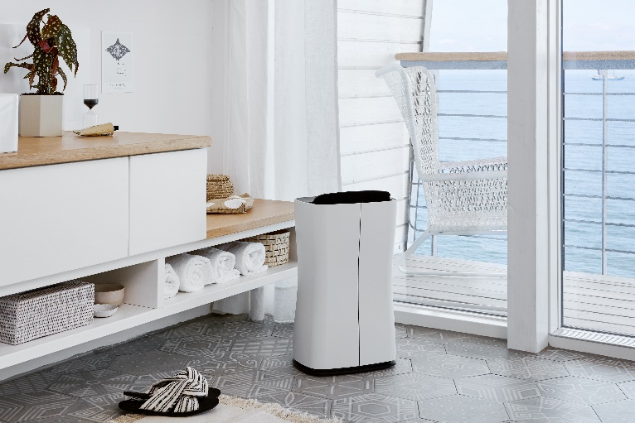
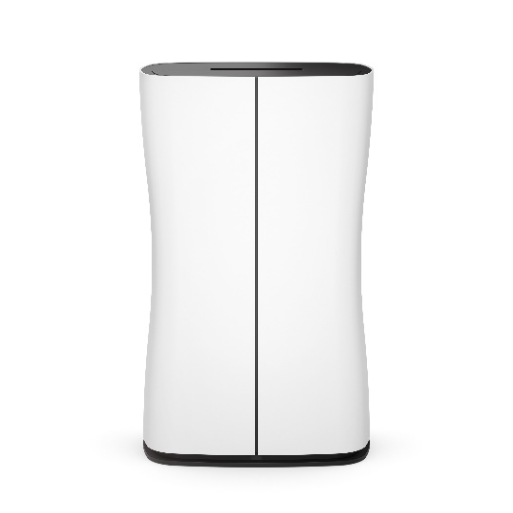

Albert – the intelligent dehumidifier

The current Green Living design trend is based around filling your home with houseplants of different sizes. Albert from Stadler Form can help make sure that your indoor air quality is not affected by the increased humidity. If the humidity is below the recommended 60%, silence prevails – unless the hygrostat is randomly turned up to 80%. The ingenious Albert switches on independently as soon as air values deteriorate. The dehumidifier sucks in the air enriched with small water droplets, captures them and distributes the dehumidified air back into the room using his swing mode. In addition, the hose enables drainage to continue without you having to empty the tank. Albert is particularly suitable for rooms of up to 70 m².

That’s not all: the swing mode circulates the indoor air so that washing dries quicker and evenly.

Dehumidifier Albert from Stadler Form, current market price Fr. 424.00

Click here to watch a video that showcases all Albert’s functions.
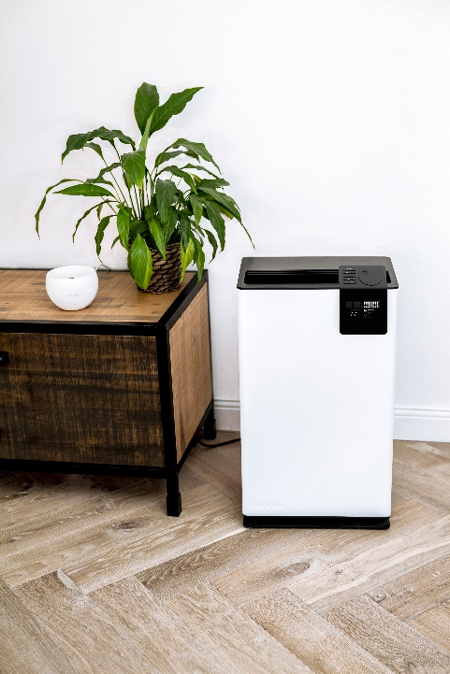

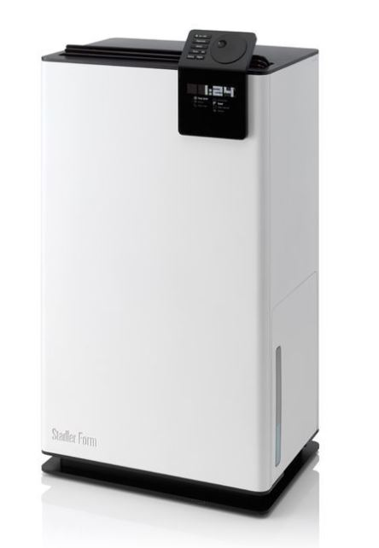

Dehumidifiers Theo and Albert were designed by Swiss designer Matti Walker working in partnership with Stadler Form.

Theo and Albert are available via stadlerform.com and in selected specialist stores as well as their online shops.

Please do not hesitate to contact us for further information.

Press contact:
Silvia Acerra | Flowcube Communications | E-mail: silvia.acerra@flowcube.ch |
Tel. +41 (0)43 344 30 35

