TRENDLETTER I Summer 2024

Enjoy the summer with a fresh breeze

Stadler Form presents the fans Finn & Finn mobile, Simon, Peter little and Leo
When the temperatures rise outside, we look forward to sunny days and warm evenings. But the heat often brings challenges: indoors, on the balcony or on the terrace, it can become uncomfortably hot and stuffy, which leads to discomfort and tiredness. You can counteract this with good air circulation. Stadler Form has designed the right fan for every type of interior and every need to ensure pleasant refreshment at home, in the office and in covered outdoor areas.

The flexible Finn and Finn mobile

Both Finn and Finn mobile are versatile and can be used as pedestal, floor or table fans. With their detachable pole, they can be positioned in different living spaces to suit individual preferences in no time at all. The very low power consumption from 1.6 watts makes them extremely energy-efficient fans. When the air is stagnant in summer, it can get stuffy on the balcony or on the patio. Finn mobile is the first fan from Stadler Form that also provides pleasant refreshment in covered outdoor areas thanks to his battery operation and IP44 certification.

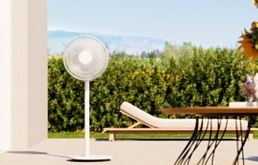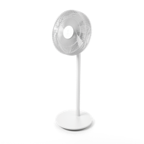

Fan Finn from Stadler Form, current webshop price Fr. 114.–
Fan Finn mobile from Stadler Form, current webshop price Fr. 159.–
Click here for the video of Finn on YouTube

The powerful Simon

When temperatures are high, the air in the room should not stand still. This is because circulating air feels cooler than stagnant air. Simon from Stadler Form is quiet, has plenty of power and, thanks to his 3D oscillation, ensures optimum distribution of the airflow throughout the room. As soon as
Simon is switched on, the fan head moves horizontally and vertically in both directions in swing mode and reaches everyone in the room with a wind distance of up to 10 meters. Simon is also a true design object: his anthracite-coloured, modern textile cover and futuristic shape make him an eye-catcher.

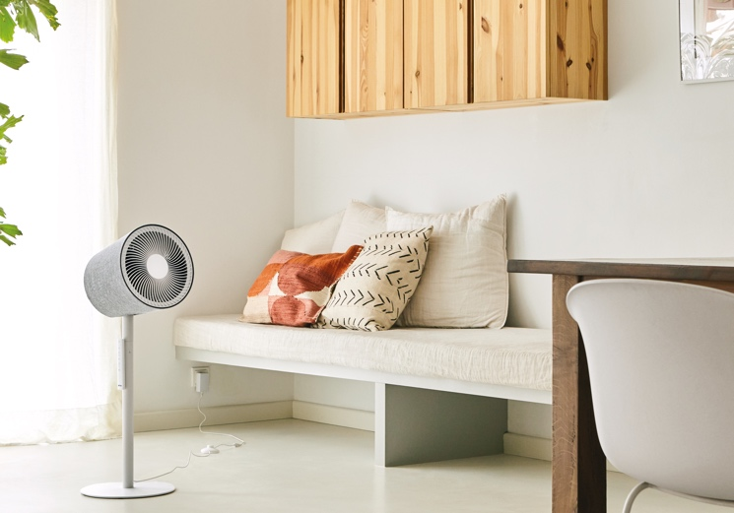
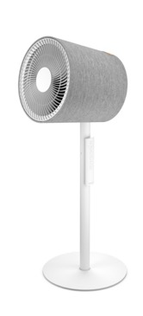

Fan Simon from Stadler Form, current webshop price Fr. 199.–
Click here for the video of Simon on YouTube

The practical Peter little

The stylish table fan Peter little impresses with his clear shape and minimalist design. With his compact size, he can be placed in the bedroom, on the office desk or next to the sofa. Thanks to his swing mode, he distributes the airflow particularly evenly. The touch panel can be used to adjust the wind speed in four levels, from a gentle breeze to a stronger gust of wind. Peter little also simulates the wind conditions on the beach in natural breeze mode, creating a holiday atmosphere within your own four walls.

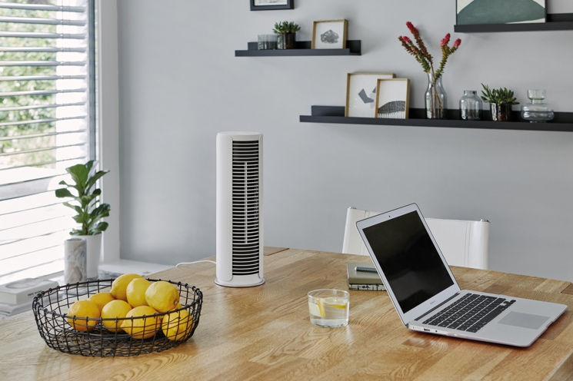
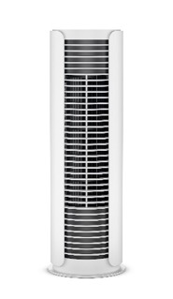

Fan Peter little from Stadler Form, current webshop price Fr. 74.30

The stylish Leo

Like Simon, Leo from Stadler Form uses 3D oscillation to circulate the airflow not only horizontally but also vertically in the room. The result is an all-round freshness with a wind distance of eight meters. The practical leatherette carrying handle makes Leo particularly mobile and versatile for use in the living room, bedroom or office. Four different speed levels can be set – also conveniently with the

practical remote control, which adheres magnetically to Leo. At the highest setting, strong gusts of wind are simulated, creating a special beach feeling.

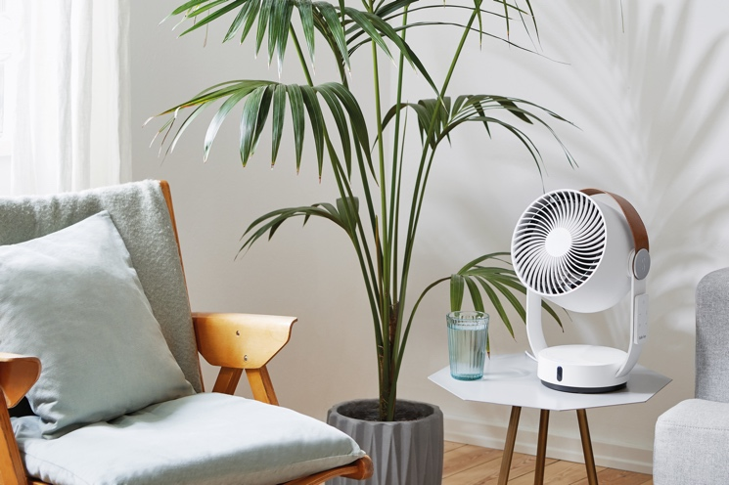
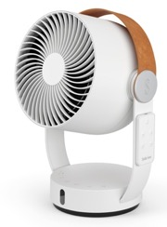

Fan Leo from Stadler Form, current webshop price Fr. 109.–
Click here for the video of Leo on YouTube

The fans Finn & Finn mobile, Simon, Peter little and Leo from Stadler Form are available on
stadlerform.com, in selected specialist shops and their online shops.

Please do not hesitate to contact us for further information.

Media contact

Silvia Acerra
Flowcube Communications | E-Mail: silvia.acerra@flowcube.ch | Tel. +41 (0)43 344 30 35

